**BeHive-E环境控制主机**

**BeHive-E Environmental Control Unit**

**使用说明书**

**Instruction Manual**

|  |  |  |  |  |  |
| --- | --- | --- | --- | --- | --- |
| 编 制 |  | 审 核 |  | 批 准 |  |
| 日 期 |  | 日 期 |  | 日 期 |  |
| 发放范围 |  | | | | |

# 编辑历史

|  |  |  |  |  |
| --- | --- | --- | --- | --- |
| 编辑历史： | | | | |
| 编辑时间 | 版本 | 作者 | 编辑内容 | 审核人 |
| 2022.11.24 | V1.0 | 邱逸杰 | 初稿发行 |  |
| 2022.12.15 | V1.0 | 黄华 | 中英文对照版本 |  |
| 2022.12.15 | V1.0 |  | 5处修改，具体见修订 |  |
| 2022.12.16 | V1.01 |  | 具体见修订 |  |
| 2022.12.16 | V1.01 | 黄华 | 翻译修订内容 |  |
|  |  |  |  |  |
|  |  |  |  |  |
|  |  |  |  |  |

目录 Contents

编辑历史 2

1. 系统介绍System Introduction 6

2. 典型配置图System Diagram 6

3. 设备外观介绍BeHive-E Device Introduction 7

4. 屏幕介绍BeHive-E Screen Display 9

4.1. Sensor List 传感器列表 10

4.2. Device List 设备列表 10

4.3. Light List 灯光列表 10

4.4. QR Code 10

4.5. Update Firmware 11

4.6. CO2 Calibration 11

5. 注册设备 Registration 11

5.1. 传感器安装 Sensor Installation 11

5.2. 设备控制器安装 Device Module Installation 12

5.3. 灯具控制器安装Lighting Module Installation 13

6. 报警干接点 Alarm Dry contact 13

7. SD卡 13

8. 常见问题排查 Troubleshooting 13

8.1. 传感器添加失败Sensor Installation Failure 13

8.2. 设备添加失败Device Module Installation Failure 14

8.3. 灯具添加失败Lighting Module Installation Failure 14

9. BeHive安装说明BeHive Installation Instructions 15

9.1. 安装方法1 Installation method 1 15

9.2. 安装方法2 Installation method 2 16

9.3. 安装方法3 Installation method 3 17

10. 附录: 手机 APP使用说明书 18

11. 前期准备 Registration 18

11.1. APP下载 APP Download 18

11.2. 注册APP账号 Account Registration 19

12. 绑定设备Binding Devices 20

13. 手机APP APP Introduction 23

13.1. 首页 Home Page 23

13.2. 温度设置Temperature Setting 26

13.3. 湿度设置Humidity Setting 27

13.4. CO2设置 CO2 Setting 28

13.5. VPD 29

13.6. 灯光设置Lighting Control 31

13.7. 日历 Calendar 32

13.8. 设备列表 Device List 35

13.9. 系统设置 38

13.10. 报警相关 Alarm Setting 40

13.11. APP设置 APP Setting 41

14. 附录:现场主机 APP使用说明书 Master Controller Instruction 42

14.1. Home Page 42

14.2. Calendar 45

14.3. 温度设置 Temperature Setting 48

14.4. 湿度设置 Humidity Setting 50

14.5. CO2设置 CO2 Setting 50

14.6. VPD 51

14.7. 光照设置 Lighting Control 52

14.8. 设备列表 Device List 53

14.9. 系统设置 BeHive System Setting 58

14.10. 报警相关 Alarm Setting 60

14.11. APP设置 63

14. 附录:现场主机使用说明书 BeLeaf Master Controller Instruction 37

14.1. 主页Home Page 37

14.2. 种植计划 Calendar 39

14.3. 温度设置 Temperature Setting 41

14.4. 湿度设置 Humidity Setting 43

14.5. CO2设置 CO2 Setting 43

14.6. VPD 44

14.7. 光照设置 Lighting Control 46

14.8. 设备列表 Device List 47

14.9. 系统设置 BeHive System Setting 51

14.10. 报警相关 Alarm Setting 52

14.11. APP设置 APP Setting 55

# 系统介绍System Introduction

Beleaf系统是特别针对室内种植而开发的一套环境控制系统。可实现多个种植房间或者区域的温度、湿度、光照、二氧化碳功能，满足各类中小型种植用户的需求。

Beleaf系统由现场管理主机（BeLeaf Master）、控制主机（BeHive-E）、传感器、执行设备控制器、手机APP、路由器以及云端网络服务器组成，传感器主要采集温度、湿度、光照、二氧化碳，执行设备控制器主要是根据客户需求智能控制温度、湿度、光照、二氧化碳的值，实时性高，现场管理主机以及手机APP能够记录30天的传感器数据，满足客户远程监控，便捷控制，安全性稳定性好，减少人力成本投入。

BeLeaf系统的控制主机支持连接并控制16台环境控制设备，连接10个各类型环境传感器，并控制2路灯光。

BeLeaf system is a comprehensive agricultural environmentalcontrol system developed by Pro-Leaf especially for indoor growingfacility, which integrates environmental control and irrigation control.

BeLeaf system consists of on-site Management Unit (BeLeaf Master), Control Unit (BeHive), Sensors, Device Station, Mobile APP, Router and Cloud Base Server. It allows real-time monitoring and control of grow environmental parameters such as temperature, humidity, light, CO2 and irrigation planin multiple growing areas, satisfying the control needs of hobbyists to professional growers. on-site Management Unit and Mobile APP can record sensor data for 30 days, which can help customers' remote monitoring, control, good security and stability, and reduce labor cost.

BeLeaf system control unit can connect up to 16 environmental control devices, connects 10 environmental sensors of various types and controls 2-lines of lighting.

BeHive-E环境控制主机技术参数

BeHive-E Environmental Control Unit Specifications

|  |  |
| --- | --- |
| 名称 | BeHive-E |
| 型号 | BLH-E |
| 尺寸 | 186*87.9*32.2 mm |
| 防护等级 | IP20 |
| 工作温度 | 0~50摄氏度 |
| 工作湿度 | ≤90%,不冷凝 |
| 工作电压 | DC24V |
| 工作电流 | ≤50mA（未接传感器、设备） |
| 电源适配器输入 | DC24V，2A，接口：DC005-2.5 |
| 屏幕 | 1.7寸黑白液晶显示器，分辨率：128*64，白色背光 |
| 网络接口 | RJ45 |
| 传感器接口 | RJ12,6P6C，RS485，输出电源电压：24V，输出电源电流：0.5A |
| 设备器接口 | RJ12,6P6C，RS485，输出电源电压：24V，输出电源电流：0.5A |
| 灯控器接口 | RJ12,6P6C，RS485，输出电源电压：24V，输出电源电流：0.5A |
| NC/NO接口 | 干接点报警输出，负载电压：≤30V;负载电流：≤1A |
| 传感器接入数量 | 总数不超过10个，且总电流不超过0.5A  可接四合一传感器BLS-4、（电流限制，数量不超过10个）  PAR光照传感器BLS-PAR（支持1个）、  烟雾传感器BLS-SD、  氧气传感器BLS-O2、  漏水传感器BLS-WD |
| 设备接入数量 | 总数不超过16 ,且总电流不超过0.5A（当设备耗电可能超过0.5A时设备需自带电源）  AC Remote Station (BTS-AR)、  Thermostat Station (BTS-1) 、  Temperature Device Station-Cooling（BTS-C1）  Temperature Device Station-Heating（BTS-H1）  Humidity Device StationDehumidification （BHS-D1）  Humidity Device Station-Humidification（BHS-H1）  CO2 Device Station ,PPM Up (BCS-PU1)  CO2 Device Station ,PPM Down (BCS-PD1)  Program Device Station (BPS-1)  Dry Contact Station (BDC-4)  Smart Socket 120-240V ( BSS-4)  RS485 Converter (BRC-1) |
| 灯控接入数量 | 最多2个  Light Adapter (LDA-1) |
| 通讯参数 | RS485主机,波特率9600,无校验，8位数据1位停止位 |
| 认证 | ETL，FCC，CE |

# 典型配置图System Diagram

系统连接图如下图：

BeLeaf system connection diagram:

多区域系统组成图：

Multi-zone system connection diagram:

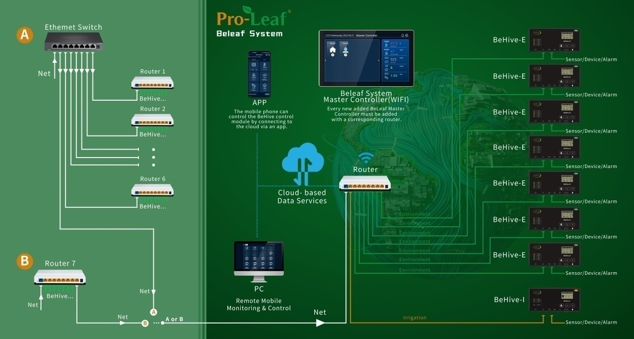

特别注意: 现场管理主机的无线必须和管理的Behive-E连接在同一个无线网络中。

Note: The on-site management unit (BeLeaf Master) and Control Unit (BeHive) must be connected to the same wireless network.

# 设备外观介绍BeHive-E Device Introduction

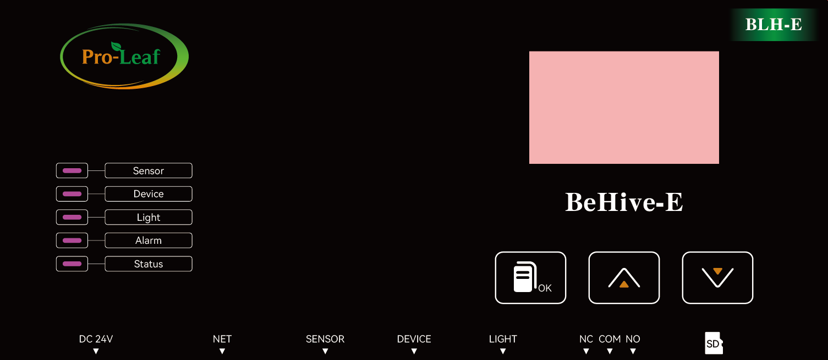

屏幕 Screen

确认键 Confirm

向下键 Downward

向上键 Upward

心跳灯

报警灯

传感器指示灯灯 Sensor Indicator

灯光指示灯

设备指示灯

灯光485接口

Light Port

设备485接口

Device Port

传感器485接口

Sensor Port

网络口

Network Port

24V电源接口

24V Power Input

报警干接点接口

Alarm Dry Contact

SD卡插槽

SD Card Slot

**传感器指示灯**：如果没有注册任何传感器，灯为灭的状态，如果存在已经注册的传感器，灯为常亮，如果有注册传感器时灯会闪烁一下。

**Sensor Indicator:** This indicator will only be on if there is a successfully registered sensor, and will blink when user try to register a new sensor.

**设备指示灯**：如果没有注册任何设备，灯为灭的状态，如果存在已经注册的设备，灯为常亮，如果有注册设备时灯会闪烁一下。

**Device Indicator:** This indicator will only be on if there is a successfully registered devices, and will blink when user try to register a new devices.

**灯光指示灯**：如果没有注册任何灯光设备，灯为灭的状态，如果存在已经注册的灯光设备，灯为常亮，如果有注册灯光设备时灯会闪烁一下。

**Light Indicator:** This indicator will only be on if there is a successfully registered light, and will blink when user try to register a new light.

**报警灯**：如果有报警信息，该灯会闪烁。

**Alarm Indicator:** This indicator will flash if there is an alarm message.

**心跳灯**：软件正常运行的时候，灯光会一直慢闪。

**Breathing Indicator:** The light will keep flashing slowly when the system is running normally.

**屏幕**：显示本机的实时环境采集数据、设备注册情况、灯具注册情况，并显示本机的QR Code，CO2设备校准及软件更新状态。

**Screen:** It shows the sensor data, device registration status, light registration status, QR code, CO2 sensor calibration status and firmware update status.

**确认键：**短按进入下一级界面，长按1秒退出。

**Confirm Key：**Short press to enter next level page, long press for 1 second to exit.

**向上键：**选择目录。

**Upward:** Upward selection

**向下键：**选择目录。

**Downward:** Downward selection

**24V电源接口：**电源适配器接口，电源适配器选择电压24V、电流2A。

**24V Power Supply Input:** Power adapter (24V@2A) interface.

**网络口：**网络线接口。

**Network Port:** Network cable interface

**传感器485接口：**接入传感器类型设备，如四合一传感器（BLS-4）、光照传感器（BLS-PAR）等。

**Sensor Port:** Interface for accessing sensors, such as the Four-in-One sensor (BLS-4), PAR sensor (BLS-PAR), etc.

**设备485接口：**接入控制类型设备，如Co2发生器（BCS-PU）、制冷模块（BTS-C）、制暖模块（BTS-H）、加湿模块（BHS-H）、除湿模块（BHS-D）、红外空调模块（BTS-AR）、4路智能排插（BSS-4）、4路干接点设备模块（BDC-4）、恒温控制器（BTS-1）等。

**Device Prot:** Interface for accessing for multiple device control modules, such as CO2 UP(BCS-PU), cooling module (BTS-C), heating module(BTS-H), humidification module (BHS-H), dehumidification module (BHS-D), Infrared AC remote module (BTS-AR), smart sockets（BSS-4）, dry contact control module (BDC-4), thermostat controller (BTS-1) etc.

**灯光485接口：**接入灯光类型设备，灯光控制器（LDA）。

**Light Port:** access to lighting control module (LDA)

**报警干接点：**该干接点用于连接灯光报警设备。

**Alarm Dry Contact:** The dry contact is used to connect the alarm device

**SD卡插槽：**用于插入SD卡。

SD Card slot: insert the SD card to this slot.

# 屏幕介绍BeHive-E Screen Display

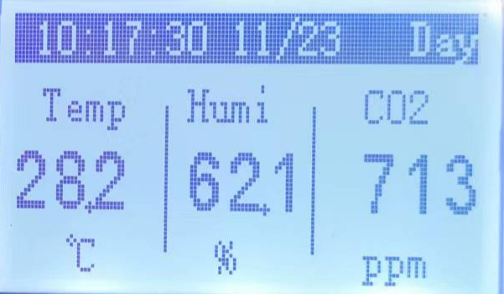

BeHive-E界面会显示系统当前的时间、白天或者黑夜，温度，湿度，二氧化碳参数。当传感器掉线或者未连接将不显示相关数值。

The BeHive-E homepage displays the current time, temperature, humidity, and CO2 real time parameters. The relevant parameter values will not be displayed when the sensor is offline or not connected.

在首页按确认键将会进入设备功能界面，以便客户查看系统的硬件连接状态和基础功能。

Pressing the Confirm button on the homepage will enter the device function menu, so that growers can check the hardware connection status and some basic functions of the system.

从上到下依次为Sensor List、Device List、Light List、QR Code、Update Firmware、CO2 Calibration。

From top to bottom are Sensor List, Device List, Light List, QR Code, Update Firmware, CO2 Calibration.

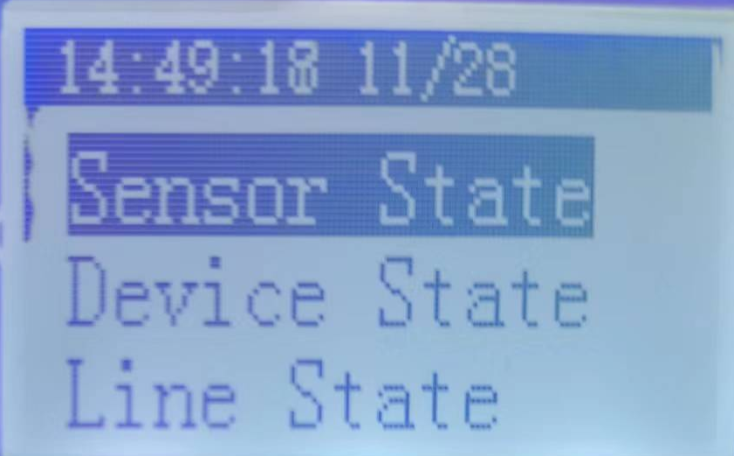

## Sensor List 传感器列表

Sensor List功能将循环显示CO2、Temp、Humi、Photocell、PPFD的具体数值，CO2、Temp、Humi、Light的数值来自于四合一传感器，PPFD数值来自PAR传感器数据，如果传感器没有注册或者掉线，将不显示相关数值。

The Sensor List display cycles through the values of CO2, Temp, Humi, Light and PPFD. If the sensor is not registered or offline, the real time values will not be displayed.

## Device List 设备列表

进入该界面后会显示当前注册的所有device，如果device在线时显示online，否则显示offline。如果当前注册的device 数量大于一个界面能够容纳的数量，则循环展示。

All registered devices are displayed on this interface. If the device is online, the device state will be online. Otherwise, the device state will be offline. If the number of registered devices is greater than the number that can be accommodated on one interface, the system displays the device state repeatedly.

## Light List 灯光列表

进入该界面后会显示当前注册的所有light，如果light在线时显示online。

All registered lighting module are displayed on this interface. If the module is online, the module state will be online. Otherwise, the module state will be offline.

## QR Code

显示本机的QR Code用于注册到后台，具体添加到后台的操作请参照《BEHIVE APP使用说明书》。

Display the QR Code of this BeHive Control Unit for registration of this control unit, please refer Mobile APP User's Manual for more information.

## Update Firmware

在该功能下可以手动升级最新的BeHive固件，BeHive将会自动下载最新的固件，完成后会提示“Download OK”。下载完成后，请重启BeHive电源，BeHive就会进入升级模式，此时指示灯会循环点亮以指示正常升级，升级完成后就会自动跳转到新版本固件，升级功能完成。

You can manually upgrade to the latest BeHive firmware by chose this function, BeHive will automatically download the latest firmware the device will display "Download OK" after the download is done. After downloading, please unplug the BeHive and re-power it again, the BeHive will enter the upgrade mode, the indicator light will light up in a cycle to indicate the BeHive is under upgrading, after the upgrade is completed, it will automatically jump to the latest version of firmware and the upgrade function is completed.

## CO2 Calibration

使用该功能需要确认将四合一传感器放置室外通风的环境下进行校准，持续一分钟直到提醒“Calibrate OK”之后。

Please place the 4 IN 1 sensor under a normal atmospheric conditions (outdoor environment) for at least for one minute unit it shows “Calibration OK”.

# 注册设备 Registration

Sensor 类设备需要接到传感器485接口，device 类设备需要接到设备485接口，light类设备需要接到灯光485接口。

Sensor need to be connected to the Sensor Port, device control module need to be connected to the Device Port, light module need to be connected to Light Port.

## 传感器安装 Sensor Installation

将传感器接入BeHive的Sensor接口后，可以在功能界面中选择Sensor List查看相应的数值。（请添加硬件连接说明，传感器连接到Sensor那个接口的图片类似那张我随便截图的图片，之后再是下面这张图片，左右并列）

User can select the Sensor List on the function menu to see the corresponding values after connecting the sensor to the BeHive.

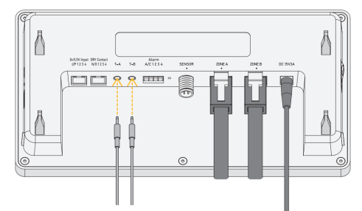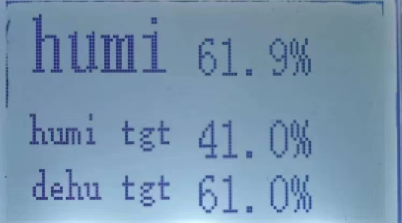

## 设备控制器安装 Device Module Installation

将设备控制器接入BeHive的Device接口后，可以在功能界面中选择Device List，就可以查看当前注册的device的连接情况了。（请添加硬件连接说明，设备控制器连接到Device那个接口的图片，之后再是下面这张图片，左右并列）

User can select the Device List on the function menu to see the connection status after connecting the device module to the BeHive.

注意: CO2 PPM UP模块（BCS-PU）、制冷模块（BTS-C）、制暖模块（BTS-H）、加湿模块（BHS-H）、除湿模块（BHS-D）是需要手动长按侧面的按键直到设备的灯一直闪烁才会发送注册命令。

NOTE: For the CO2 PPM UP module (BCS-PU), Cooling module (BTS-C), Heating module (BTS-H), Humidifying module (BHS-H), and Dehumidifying module (BHS-D), user need to manually press and hold the button on the side until the indicator of the device blinks to add it to the system.

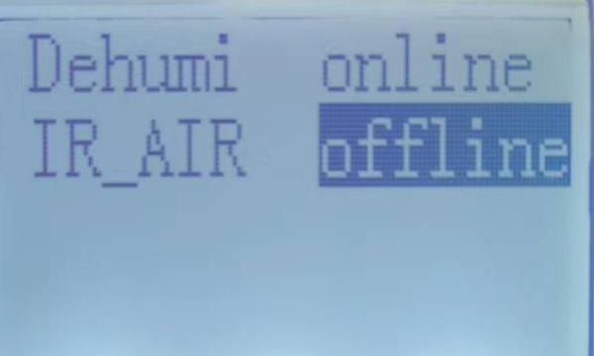

## 灯光控制器安装Lighting Module Installation

将灯光控制器接到Light接口后，可以在功能界面中选择Light List，进入界面就可以看到已连接的灯光控制器的连接状态。

User can select the Light List on the function menu to see the connection status after connecting the lighting module to the BeHive.

# 报警干接点 Alarm Dry contact

干接点接口位置，该干接点为输出CO2过高/过低报警，要使能该功能请参照《BEHIVE APP使用说明书》。干接点COM为公共端，未报警的情况下NC和COM为导通、NO和COM为不导通，如果输出报警信息时NC和COM为不导通、NO和COM导通。请注意，报警设备只能选择接入NO或者NC。

Alarm Dry contact, this dry contact is for output CO2 high limit/low limit alarm, to enable this function please refer to BEHIVE APP instruction manual. The dry contact COM is the common terminal, if there is no alarm NC and COM are on, NO and COM are not on, if an alarm message is output NC and COM are not on, NO and COM are on. Please note that alarm devices can only be connected to NO or NC.

# SD卡

SD卡存储着BeHive升级固件、设备注册信息等，在正常使用时请保证SD正常插在插槽上。

The SD card stores with BeHive firmware, device registration information,etc. Please ensure that the SD card is properly inserted in the slot during the use.

# 常见问题排查 Troubleshooting

## 传感器添加失败Sensor Installation Failure

如果插入设备5秒后看到的相对应的数值仍然显示“--”，说明没有注册成功或者插到错误的接口，如果接口是对的话，请再次插拔485接口。

Suppose the real-time value does not display on the screen 5 seconds after the sensor is inserted. In that case, it indicates that the sensor is not registered successfully or the sensor is inserted into a wrong port. If the interface is correct, please repeat the installation process.

## 设备添加失败Device Module Installation Failure

如果接入device 后发现界面没有出现对应的设备或者设备对应的状态超过10秒仍然显示offline，那么有可能是接错接口或者没有注册成功，在接口正确的情况下重新插拔接口。

注意:有的控制类如CO2发生器（BCS-PU）、制冷模块（BTS-C）、制暖模块（BTS-H）、加湿模块（BHS-H）、除湿模块（BHS-D）是需要手动长按侧面的按键直到设备的灯一直闪烁才是向BeHive-E发送注册命令，否则BeHive-E设备上面不会显示注册信息。

如果接入的设备数量累计超过16个，需要在手机端或平板上删除不用的设备，才能接入新的设备。

If there is no corresponding device on the interface after connecting to the device port, or the corresponding status of the device still shows offline for more than 10 seconds, then it may be that the wrong port is connected or the registration is not successful. Please repeat the installation process.

## 灯光控制器添加失败Lighting Module Installation Failure

如果接入Light 后发现界面没有出现对应的灯光设备或者灯光设备对应的状态超过10秒仍然显示offline，那么有可能是接错接口或者没有注册成功，在接口正确的情况下重新插拔接口。如果接入的设备数量累计超过2个，需要在手机端或平板上删除不用的设备，才能接入新的设备。

If there is no corresponding lighting device on the interface after connecting to Light, or the corresponding status of the lighting device still shows offline for more than 10 seconds, then it may be that the wrong port is connected or the registration is not successful. Please repeat the installation process.

# BeHive安装说明BeHive Installation Instructions

## 配件清单

## 

## 安装方法A Installation method A

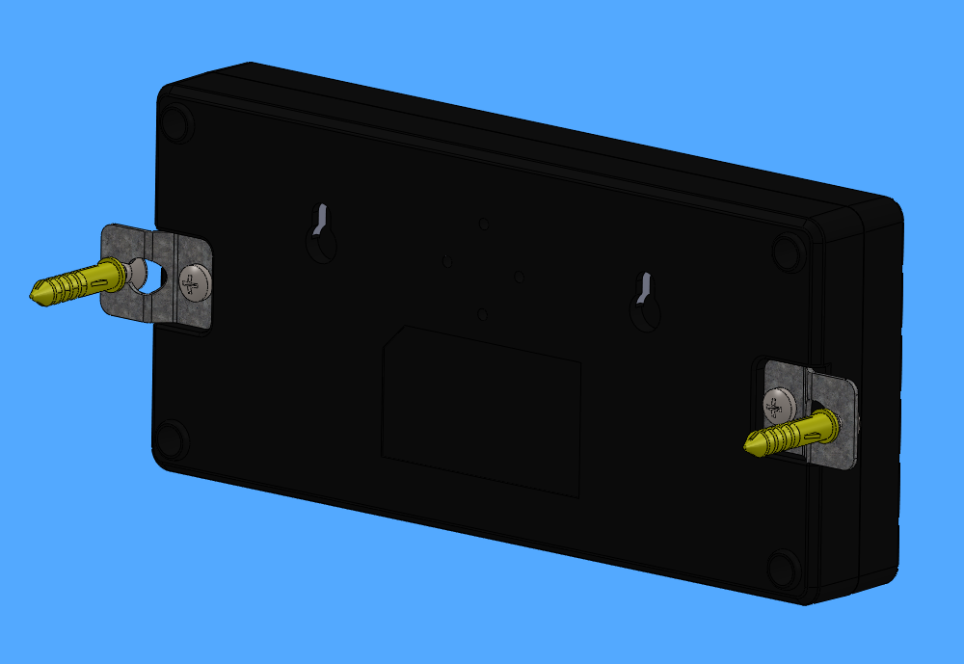

产品背面用小螺丝锁上挂片,再将挂片通过膨胀锁在墙上即可。  
User can lock the BeHive control module with the wall hanger and expansion screws.

## 安装方法2 Installation method 2

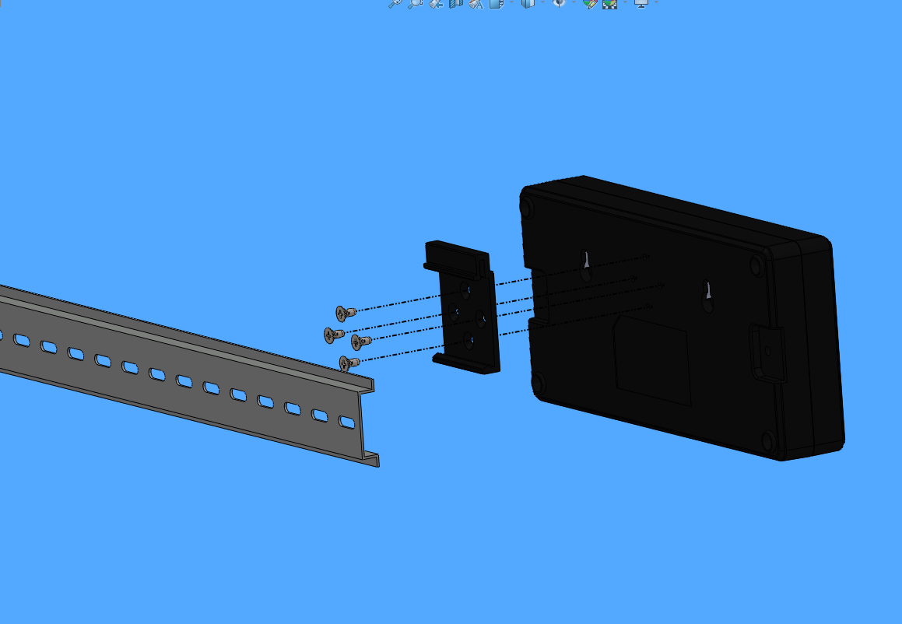

产品背面用小螺丝锁上导轨卡扣再将导轨卡扣电控箱的导轨上。

For the power distribution cabinet, the user can use the screw to lock the rail clips to the back of the control unit and then snap onto the rail in the distribution cabinet.

## 安装方法3 Installation method 3

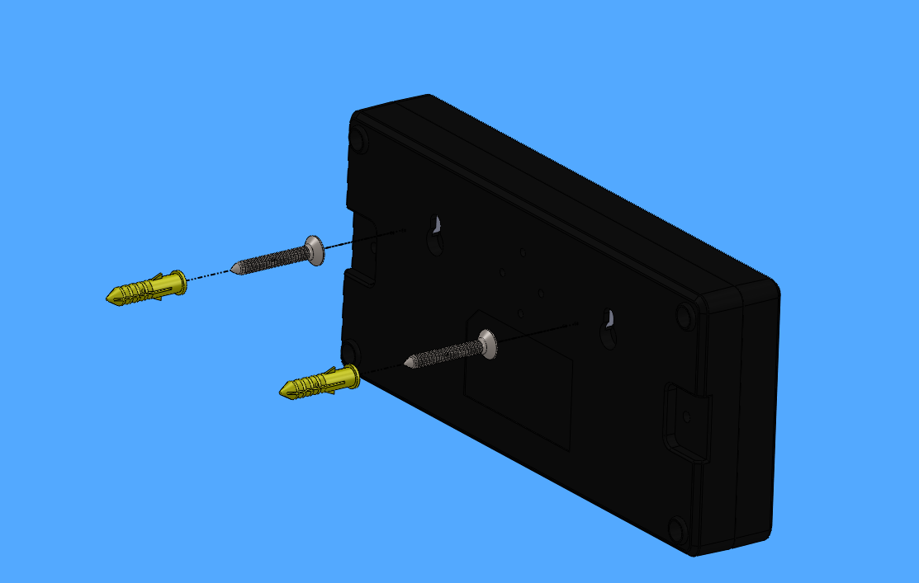

墙上锁好膨胀螺丝套装将产品挂上去即可。

User can lock the expansion screw set on the wall and hang the product.

# 附录: 手机 APP使用说明书

# 前期准备 Registration

## APP下载 APP Download





## 注册APP账号 Account Registration

登录界面点击[快速注册] Tap [Registration] on the login Page

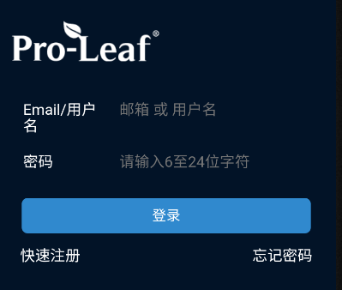

输入用户名密码邮箱，系统会自动发送验证码到您提供的邮箱，(进邮箱收取验证码，并进行后续的注册操作)使用邮箱里的验证码(可能在垃圾邮箱)，验证后完成注册，注册成功后登录APP。

Enter the Username,Password and Email, the system will automatically send the verification code to the Email you provide, use the verification code in the mailbox (may be in the spam box), verify and complete the registration, login to the APP after successful registration.

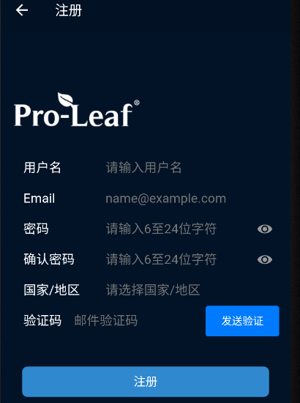

# 绑定设备Binding Devices

BeHive-E设备插上网线，选择QR Code，按确认键。

Connect the BeHive-E to the cable, select QR Code, and press the OK.

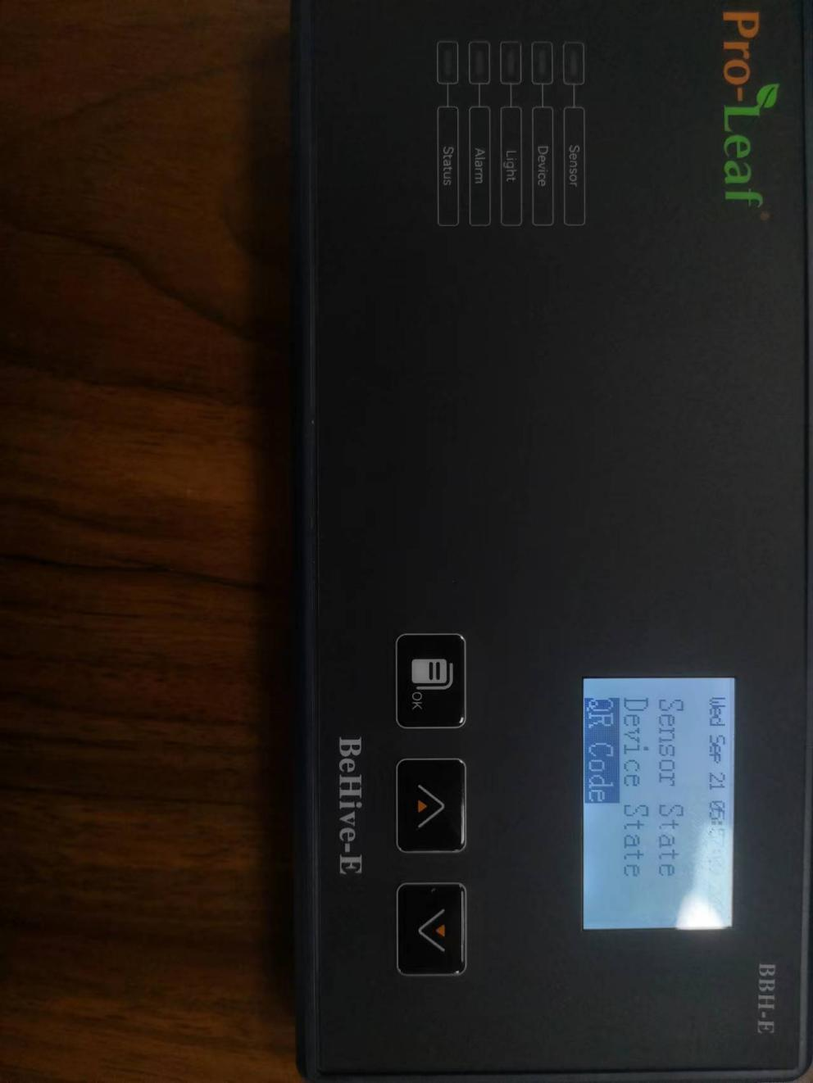

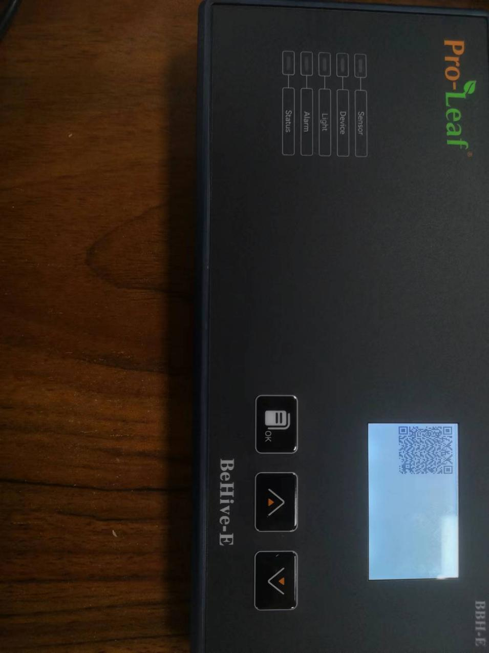

在上方获取到设备二维码后，打开手机APP，点右上角进入扫一扫页面并扫描上方的二维码。

After getting the device QR code, tap the plus sign on upper right corner of mobile app, use the scan function to scan the QR code.

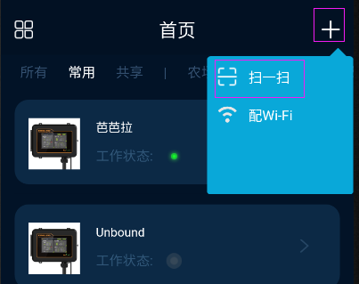

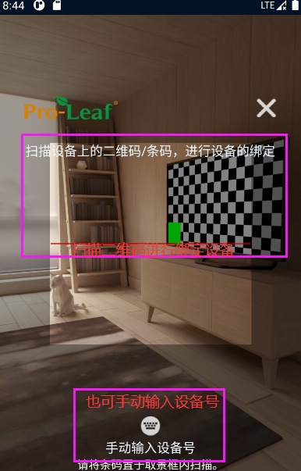

扫码或手动添加后，点击“设备未绑定”：

After scanning the QR code or adding it manually, by tap "Device Unbound".

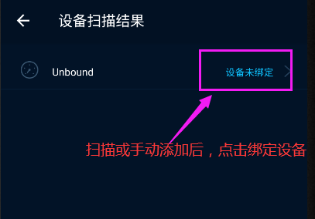

输入设备名称，选择设备区域，点确定即可绑定成功。

Enter the device name, select the device area, and tap OK to bind successfully.

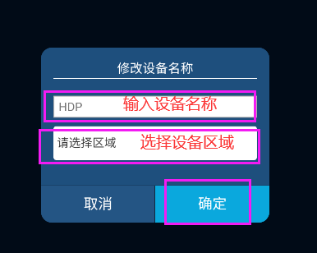

# 手机APP APP Introduction

## 首页 Home Page

打开APP，显示设备列表，点击打开BEHIVE-E设备，进入设备首页。

Log into the APP will show the list of connected devices, tap to enter the BEHIVE-E you want to set up and enter the home page of that device.

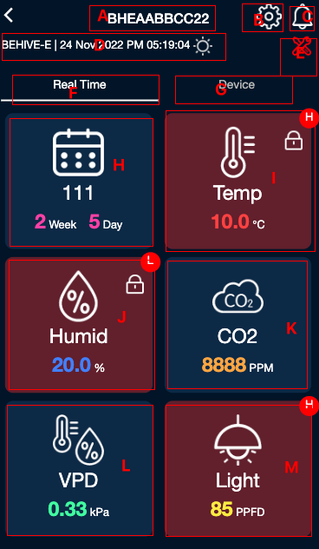

A：设备名称可点击修改。

B：设备设置。

C：警报信息可点击浏览。

D：设备型号，当前时间，白天黑夜。

E：检修模式。

F：点击查看实时参数。

G：点击查看设备列表。

H：显示当前配方及已经执行天数。

I：显示当前温度值，点击跳转到温度设置页。

J：显示当前湿度值，点击跳转到湿度设置页。

K：显示当前CO2浓度值，点击跳转到CO2设置页。

L：显示当前VPD，点击跳转到VPD详情页。

M：显示该当前光照值，点击跳转到灯光设置页。

(I~M)：报警时背景变红，右上角将显示H或L，表示过高报警或过低报警。

A: Device name top to rename.

B：Device settings.

C：Tap to browse the Alarm information.

D：Device model, current time, day or night mode.

E: Maintenance mode.

F：Click to view real-time parameters.

G：Click to view device list.

H：Display the current schedule and the number of days it has been executed.

I：The current temperature value, click to enter the temperature setting page.

J: The current humidity value, click to enter the humidity setting page.

K: The current CO2 concentration value, click to enter the CO2 setting page.

L: The current VPD, click to enter the VPD page.

M: The current light PPFD, click to enter the light setting page.

(I~M): The background turns red when alarm is on, and H or L will be displayed in the upper right corner, which means high limit alarm or too limit alarm.

向下滚动该界面可以查看该设备的历史数据。

Scroll down this page to see the historical data of this device.

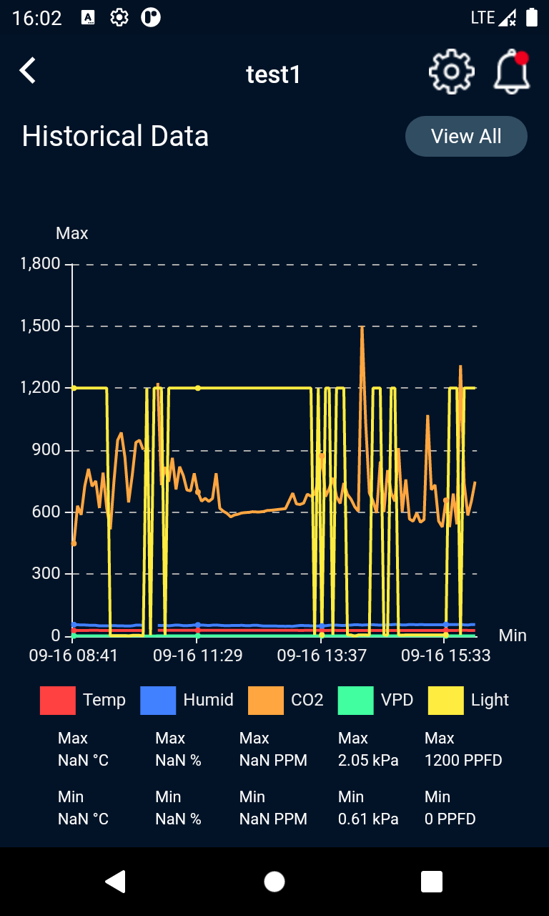

点击[View All]可进入横屏查看，并可按日/周/月查看。

Tap [View All] to go to landscape view to review the data by day/month.

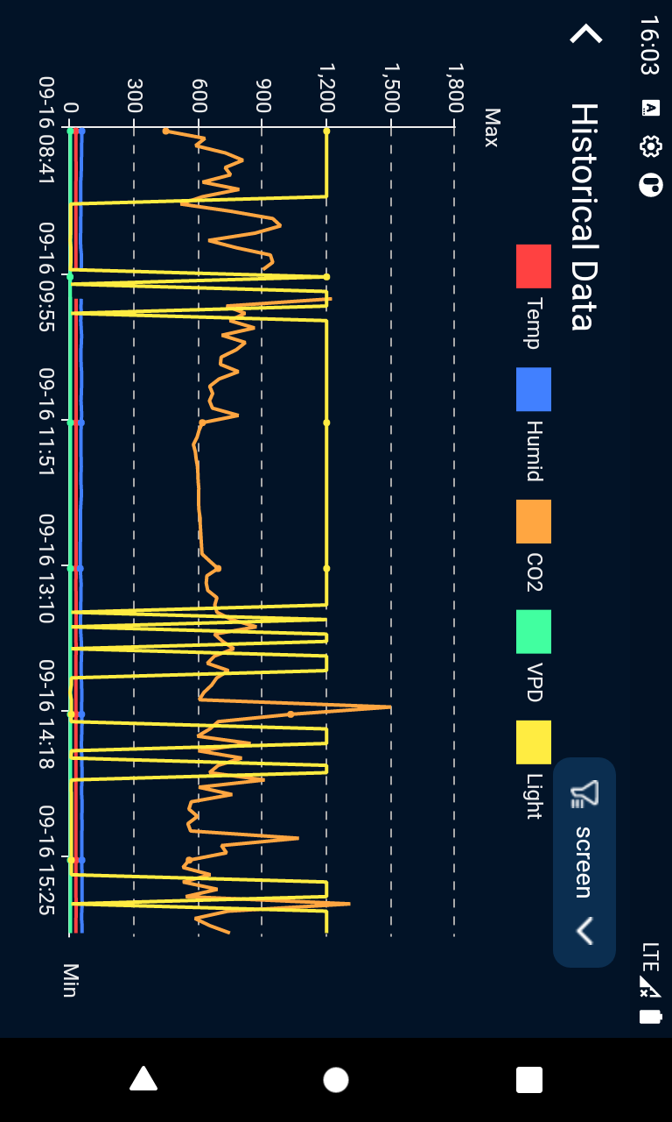

## 温度设置Temperature Setting

点击首页[Temp]进入温度设置页面。

Tap [Temp] on the home page to enter the temperature setting page.

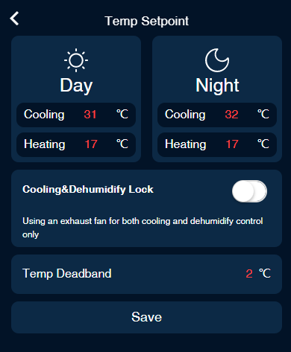

制冷触发值与制热触发值的差值必须 >= 温度Deadband*2

Cooling trigger value and heating trigger value Difference must be >= Temperature Deadband*2

制冷条件：当温度值 >= 制冷目标温度时开启，

当温度值 <= 制冷目标温度 - Deadband时关闭。

Cooling condition: Turn on when the temperature value >= Cooling Trigger Temperature

Turn off when the temperature value <= Cooling Trigger Temperature - Deadband.

制热条件：当温度值 <= 制热目标温度时开启，

当温度值 >= 制热目标温度 + Deadband时关闭。

Heating condition: Turn on when the temperature value <= Heating Trigger Temperature

Turn off when the temperature value >= Heating Trigger Temperature + Deadband.

制冷及除湿锁定：只有使用排气扇进行制冷和除湿控制时选中, 仅限于Device Station及 Smart Socket-4。

Cooling & Dehumidify lock: selected only when using exhaust fans for cooling and dehumidification control.

**举例如下：当制冷及除湿设置为锁定时，排气扇接一个Cooling的Device station 的输出，则当除湿动作被触发时，这个Cooling的Device station 也要输出，排气扇启动，即使此时Cooling的条件并没有被触发。**

**Example: When Cooling and Dehumidify are set to lock, the exhaust fan is connected to the output of a Cooling Device station(BTS-C), so that when dehumidification is triggered, the Cooling Device station(BTS-C) is also turn on the exhaust fan, even if the cooling condition is not triggered at this time.**

## 湿度设置Humidity Setting

点击首页[Humid]进入湿度设置页面。

Tap [Humid] on the top page to enter the humidity setting page.

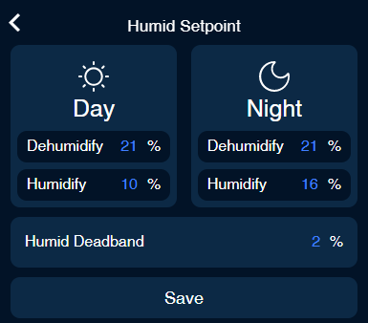

除湿条件：当湿度 >= 除湿目标值时开启，

当湿度 <= 除湿目标值 - Deadband时关闭。

Dehumidification condition: Turn on when humidity >= Dehumidification Trigger Value

Turn off when Humidity <= Dehumidification Trigger Value - Deadband.

加湿条件：当湿度 <= 加湿目标值开启，

当湿度 >= 加湿目标值 + deadband时关闭。

Humidification conditions: Turn on when humidity <= Humidification Trigger Value

Turn off when humidity >= Humidification Trigger Value + deadband.

## CO2设置 CO2 Setting

点击首页[CO2]进入CO2设置页面。

Tap [CO2] on the top page to enter the CO2 setting page.

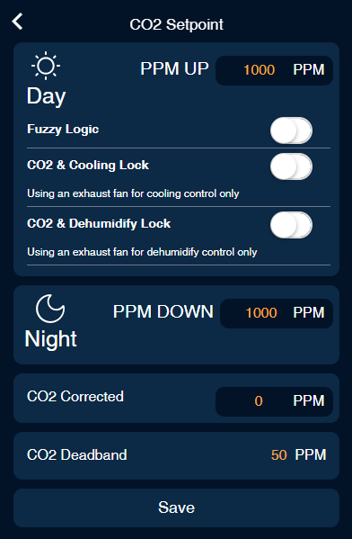

PPM UP只在白天生效

PPM UP is only effective during the daytime

PPM UP时可选择是否是Fuzzy Logic模式（使用二氧化碳钢瓶）。

Grower can select Fuzzy Logic mode when the CO2 tank is the source for PPM UP.

CO2及制冷锁定：只在使用排气扇制冷时选中。备注： 选择锁定是为减少CO2 浪费，当使用排气扇作为制冷设备时，如果触发了制冷条件，排气扇启动，则CO2 UP输出自动关闭，直到停止制冷。

CO2 & Cooling Lock: Onlyselect when using an exhaust fan for cooling. NOTE: this function is selected to reduce CO2 waste, when using the exhaust fan as a cooling device, if a cooling condition is triggered and the exhaust fan starts, the CO2 UP output is automatically switched off until cooling stops.

CO2及除湿锁定：只在使用排气扇除湿时选中。备注： 选择锁定是为减少CO2 浪费，当使用排气扇作为除湿设备时，如果触发了除湿条件，排气扇启动，则CO2 UP输出自动关闭，直到停止除湿。

CO2 and DehumidifyLock: Only selected when using an exhaust fan for dehumidification. NOTE: Lock is selected to reduce CO2 waste. When using an exhaust fan as a dehumidification device, if a dehumidification condition is triggered and the exhaust fan starts, the CO2 UP output is automatically switched off, will be back on until dehumidification stops.

CO2 UP条件：当CO2值 <= PPM UP目标值时开启，

当CO2值 >= PPM UP目标值 + CO2 Deadband时关闭。

PPM UP condition: Turn on when CO2 value <= PPM UP target value.

Turn off when CO2 value >= PPM UP target + CO2 Deadband.

**PPM Down 只在黑夜条件下生效**

**CO2 Down条件：当CO2值>= PPM Down目标值时开启，**

**当CO2值<= PPM Down目标值 - CO2 Deadband时关闭**

PPM DOWN condition: Turn on when CO2 value >= PPM DOWN target value.

Turn off when CO2 value <= PPM DOWN target - CO2 Deadband.

CO2修正值：当CO2值与标准仪器测量不一致需要校准的时候需要修正，设置修正值后，CO2实时值为CO2传感器值+修正值。

CO2 correction value: After setting the correction value, the CO2 real-time value is CO2 sensor value + correction value.

## VPD

点击首页[VPD]进入VPD页面。Tap [VPD] on the home page to enter the VPD page.

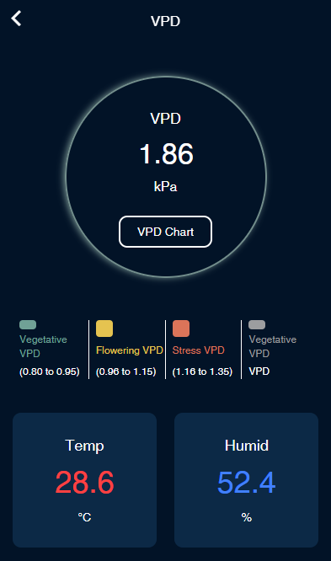

点击[VPD Chart]进入VPD图表页可作为参考值。Tap [VPD Chart] to go to the VPD Chart page as a references.

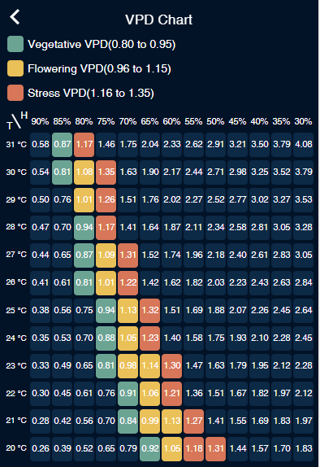

## 灯光设置Lighting Control

点击首页[Light]进入Light页面，包含线路1设置及线路2设置。

Tap [Light] on the home page to enter the Lighting control page, which shows Line 1 settings and Line 2 settings.

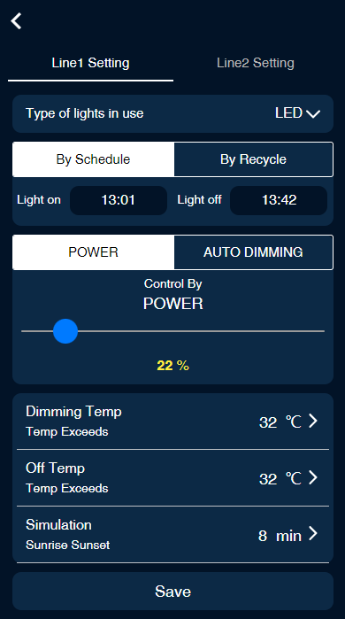

线路设定: 可以选择对线路1设置或线路2进行灯光设置

灯光类型：LED、HID。其中HID模式可设置HID Delay。

工作模式：By Schedule及By Recycle。

By Schedule：可设置几点开，几点关。每天循环。最多可设置12组定时器。

By Recycle：可设置第一次开启时间，开启时长，关闭时长。

控制模式：POWER：指定灯光输出功率百分比；AUTO DIMMING：需要有PAR传感器,使光照维持在设定的光照值下；只有Line1才有。

自动调温温度：当温度超过设置值时，灯具自动调整为设置值的一半输出，如果调整后低于40%，将设为40%

关闭温度：当温度超过设置值时，自动关闭。

模拟太阳光日升日落控制：模拟日升日落持续时间。

Line Setting: You can choose to set line 1 or line 2’s light settings

Light type: LED, HID. where HID mode can be set HID Delay.

Operating modes: By Schedule and By Recycle.

By Schedule: You can set the on time and off time. Daily cycle. Up to 12 sets of timers can be set.

By Recycle: Start time, on time duration, off time duration.

Control modes: POWER, AUTO DIMMING. where AUTO DIMMING is only available for Line1.

Automatic dimming temperature : When the temperature exceeds the set value, the fixtures automatically adjusts to 40% output.

Off temperature: Automatically turn off the fixture when the temperature exceeds the set value.

Sunrise and Sunset: Simulate the sunrise and sunset.

## 日历 Calendar

日历控制总开关，On时日程生效。

设置日程开始时间

Calendar Control Switch, schedule takes effect when On.

Set schedule start time

点击增加生长阶段：选择配方，输入持续天数。

Tap  to increase the recipe and the duration: select the recipe and enter the number of days.

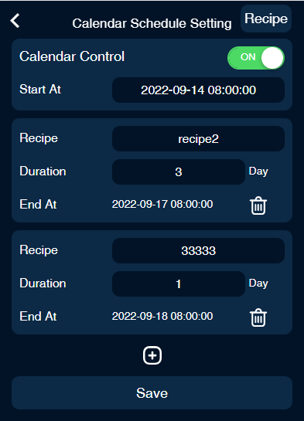

点击右上角[Recipe]进入配方列表页面。点新增配方，点删除配方。

Tap [Recipe] on the upper right corner to enter the recipe list page. Tap to add a recipe, and tap to delete a recipe.

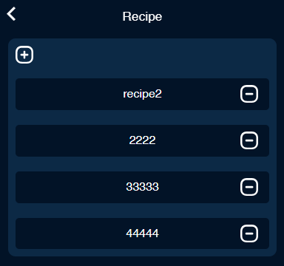

点击配方进入配方设置页面：Tap on the recipe to enter the recipe setting page:

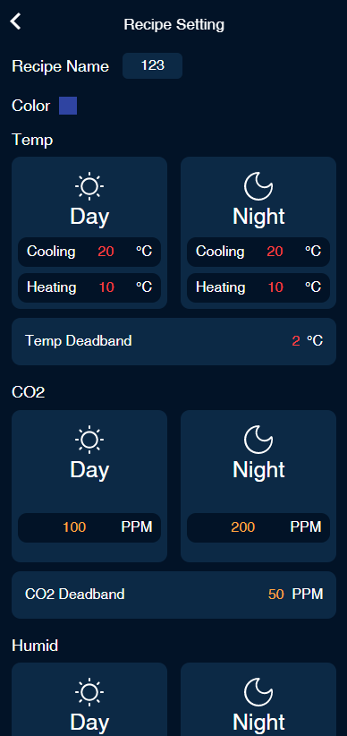

可设置配方名称、配方颜色、温度、CO2、湿度、Line1、Line2等。

User can set the Recipe Name, Recipe Color, Temperature, CO2, Humidity, Line1, Line2, etc

## 设备列表 Device List

首页点击[Device]进入设备列表。Tap [Device] on the home page to enter the device list.

设备掉线时背景变灰，掉线设备支持长按2秒删除。

Device will turn gray when it is offline, offline device can be deleted by 2 sec long press.

常开常关时右上角显示M-ON及M-OFF。

M-ON and M-OFF are displayed in the upper right corner when normally open and normally closed.

设备工作时将显示相应的工作状态。

The corresponding operating status will be displayed when the device is working.

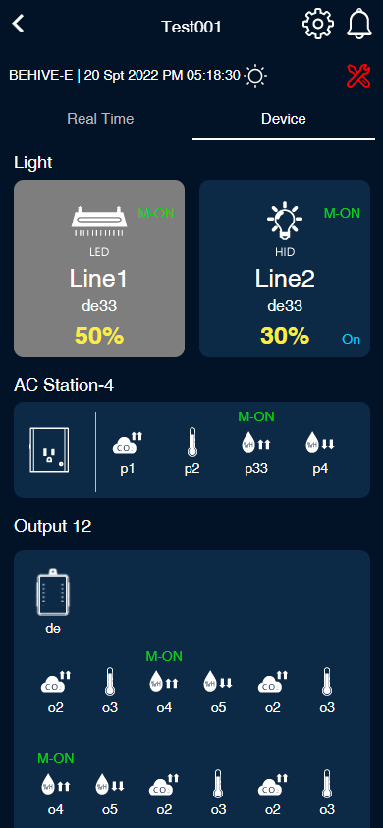

点击设备进入设备设置页面:

Tap on the device to enter the device settings page:

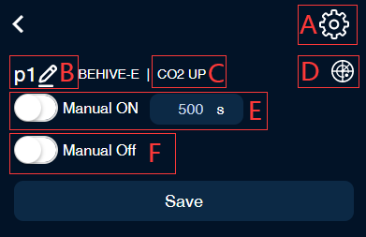

A：灯光设备/温度设备/湿度设备/CO2设备可点击进入相关的设置页。

A: Lighting device/Temperature device/Humidity device/CO2 device can tap the upper right corner to enter the setting page.

B：点击设备名称，可修改设备名称，名称规则为最多5个字符，且只支持英文数字及下划线。

B: Tap on the device name to name your device name with 5 characters max

C：设备功能类型，如果设备接在Smart Socket-4、Dry Contact-4、Control Board-12上，点击可更改端口功能类别。

C: Device type, if the device is Smart Socket-4, Dry Contact-4, Control Board-12, tap to change the port function.

D：点击可直接设备定位，定位成功时设备会持续闪1分钟。

D: Click to locate the device directly, and the device will flash for 1 minute when it is successfully located.**备注：当有多个相同类型设备同时接入主机时，利用这个功能方便找到现场对应的设备，并可点击设备名称修改设备名称或者进入设备的相应端口修改端口功能类别。**

**NOTE: When there are multiple devices of the same type connected to the host at the same time, use this function to easily find the corresponding device on site and tap on the device name to modify the device name or enter the corresponding port of the device to modify the port function category.**

E：手动开，选中后将直接开启N秒，N秒后恢复自动。

E: Manual on: will be directly opened for N seconds after selected, N seconds after restoring automatic.

F：手动关，选中后关闭设备。

F: Manual Off: Turns off the device when selected.

Hot Start Delay：除湿设备、制冷设备、制热设备可选。

Hot Start Delay: Optional function for Dehumidification equipment, cooling equipment, heating equipment.

定时设备可设置By Schedule/By Recycle。The program device can be set By Schedule/By Recycle.

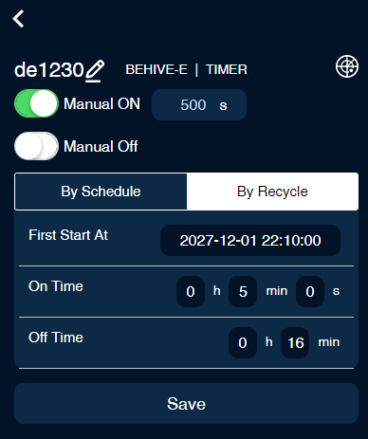

**By Schedule：可设置几点开，开多久**。每天循环。最多可设置12组定时器。

By Recycle：可设置第一次开启时间，开启时长，关闭时长。定时设备常开设置：On Time>0 且Off Time = 0。

By Schedule: set the start time, on time and off time. Daily cycle. Up to 12 sets of timers can be set.

By Recycle: set the start time, and on time duration, off time duration. After turning on, it will continuously cycle the on time and off time.

Hvac设备设置界面：HVAC device setting page:

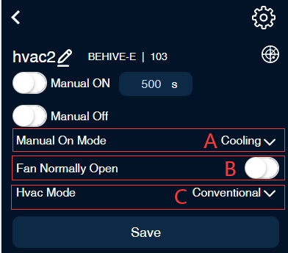

A：HVAC手动开模式有两种：Cooling、Heating。

A: HVAC has two manual on modes: Cooling, Heating.

B：可选择风扇是否常开，选中就是常开, 未选中是自动。

B: Select whether the fan is normally on. If yes, the fan is normally on. If no, the fan is under auto mode.

C：HVAC模式：Conventional、Heat PUM O、Heat PUM B。

C: HVAC mode: Conventional, Heat PUM O, Heat PUM B.

## 系统设置

设备首页点击右上角，进入系统设置页面。Tap on the top right corner of the device home page to enter the system settings page.

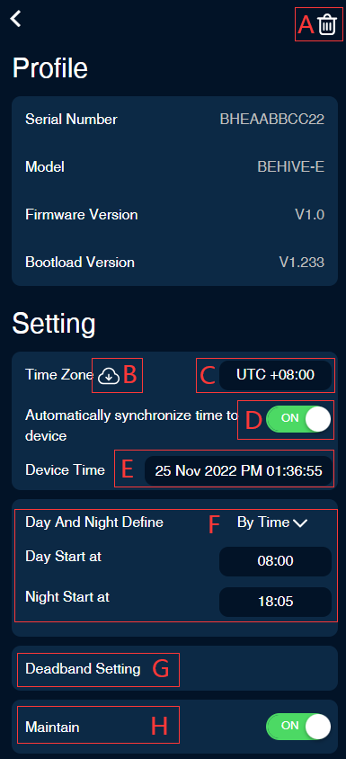

A：可解绑设备。

A: Delete this Device

B：点击可根据C设置的时区从云端同步时间至设备。

B: Tap to sync the time from the internet.

C：设置设备所在的时区。

C: Set the time zone where the device is located.

D：On时每次设备上线时将自动根据C设置的时区从从云端同步时间至设备。

D: Automatically synchronize network time to the device when it is on.

E：设置设备时间。

E: Manually set the time

F：白天黑夜定义：By Photocell/By Time。

F: Define the Day and night By Photocell or By Time.

By Photocell：根据设置的Photocell Sensitivity，与当前的Light Intensity比较，大于等于时是白天，其它是夜晚。

By Photocell: According to the set Photocell Sensitivity, compare with the current Light Intensity, it is daytime when it is greater than or equal to, and other is nighttime.

By Time：设置白天起始时间，晚上起始时间。

By Time: Set the daytime start time and nighttime start time.

G：死区值设置：可设置温度、湿度、CO2死区值。

G: Deadband value : Temperature, humidity and CO2 deadband values can be set here.

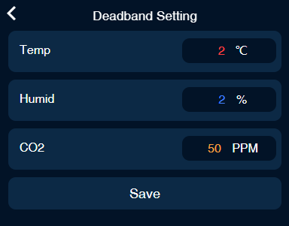

H：检修模式，选中后所有设备将停止工作，只监测数据。同时首页将会显示检修标志。

H: All devices will stop working and only data will be monitored when it is on.

## 报警相关 Alarm Setting

首页点击进入报警列表页。

Tap the  icon on the homepage to enter the alarm list page.

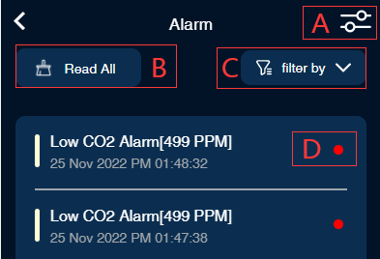

A：点击进入报警设置页面，可对温度、湿度、CO2等报警开关及报警上下限设置。

A: Tap to enter the alarm setting page, you can switch on/off the alarm and the day/night MIN and MAX alarm limits for temperature, humidity, CO2, VPD and PAR.

B：标记全部已读，点击后所有信息将全部已读。

B: Read All: All messages will be read when you click on them.

C：下拉可按设备，温度，湿度，CO2等过滤相关报警信息。

C: Scroll down to filter alarm information by device, temperature, humidity, CO2, etc.

D：有红点时表示信息未读，点击后已读，红色标记将消失。

D: Indicates that the alarm message has not been read, and the red mark will disappear when it has been read after clicking.

报警设置页面：

Alarm setting page:

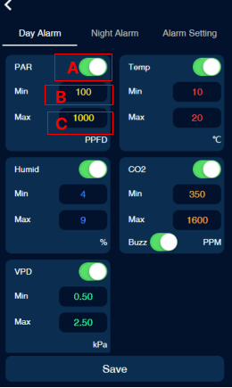

A:对应模块报警开关。

A: Switch on/off the alarm

B:对应模块报警最低值，低于或等于该值且开关开启，则发出该报警。

B: Day/Night MAX alarm limits

C:对应模块报警最高值，高于或等于该值且开关开启，则发出该报警。

C: B: Day/Night MIN alarm limits

## APP设置 APP Setting

打开APP，点击最下方进入APP设置页面。

Open the APP, tap the  to enter the APP setting page.

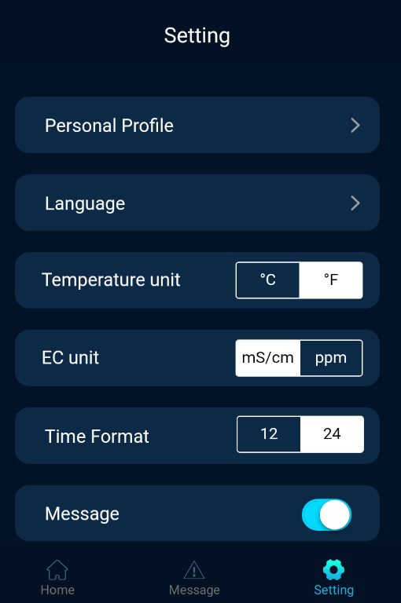

个人资料: 用户的个人信息

语言: 可根据用户的需求选择软件的语言

温度单位: 可根据用户的需求选择温度单位

EC单位: 可根据用户的需求选择EC单位

时间格式:可根据用户的需求选择时间格式

消息开关：打开时有报警信息将会发向用户发送邮件。

Personal Profile: Personal information of users

Language: users can select the language according to their needs

Temperature units: users can select the temp units according to their needs

EC units: user can select the EC units according to the their needs

Time format: users can select the time format according to their needs

Message: an alarm message will be sent to the user when it’s switch on

# 附录: BeLeaf管理主机使用说明书

# BeLeaf Master Controller Instruction

## Home Page

打开app，显示设备列表Log into the APP will show the list of connected devices.

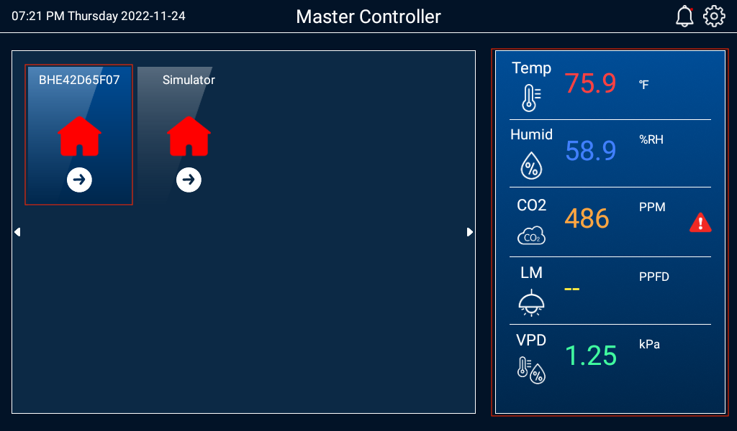

左侧为设备列表，右侧蓝色区域为当前选中设备的预览信息。

The left side is the device list (zone list), and the right side is the preview information of the currently selected device(zone).

选择BHE设备进入设备详情

Select the BHE device to enter the device(zone)setting page

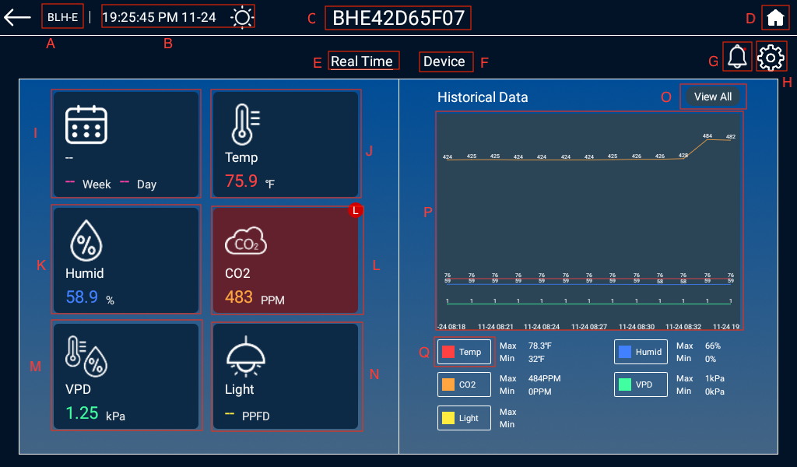

1. 设备型号；Device Model
2. 设备日期和时间；Current time and day/night mode
3. 设备名称，点击可修改；Device name top to rename
4. 返回设备列表页面；Homepage
5. 设备实时参数；Real-time Parameters
6. 设备管理列表；Device Management List
7. 警报列表,有未读报警信息时右上角将显示红点图片 25；Alarm list, red dots will be displayed in the upper right corner if there is unread alarm information;
8. 设备设置；BeHive Setting
9. 日历：日历开启的时候，这里将显示当前配方，已经执行到第几周第几天。Display the current schedule and the number of days it has been executed when the Calendar Function is activated.

报警时背景变红，右上角将显示H或L，表示高报警或低报警。The background turns red when alarm is on, and H or L will be displayed in the upper right corner, which means high limit alarm or too limit alarm.

J.温度：报警时背景变红，右上角将显示H或L，表示高报警或低报警。Temperature: The background turns red when alarm is on, and H or L will be displayed in the upper right corner, which means high limit alarm or too limit alarm.

K.湿度：报警时背景变红，右上角将显示H或L，表示高报警或低报警。Humidity: The background turns red when alarm is on, and H or L will be displayed in the upper right corner, which means high limit alarm or too limit alarm.

L.CO2:报警时背景变红，右上角将显示H或L，表示高报警或低报警。CO2: The background turns red when alarm is on, and H or L will be displayed in the upper right corner, which means high limit alarm or too limit alarm.

M.VPD:报警时背景变红，右上角将显示H或L，表示高报警或低报警。VPD : The background turns red when alarm is on, and H or L will be displayed in the upper right corner, which means high limit alarm or too limit alarm.

N.灯光：报警时背景变红，右上角将显示H或L，表示高报警或低报警。Light: The background turns red when alarm is on, and H or L will be displayed in the upper right corner, which means high limit alarm or too limit alarm.

O.实时值曲线图详情，可按日/周/月查看；Real-time data graph can be viewed by day/week/month

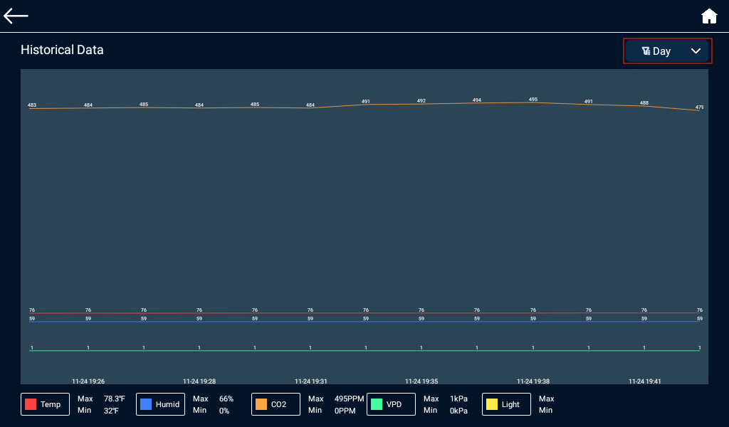

P.实时值曲线图，可左右滑动查看历史数据；Graphs of real time values, with left and right swipes to view historical data.

Q.点击可开启相应的过滤功能；Click to enable the appropriate filtering function.

## Calendar

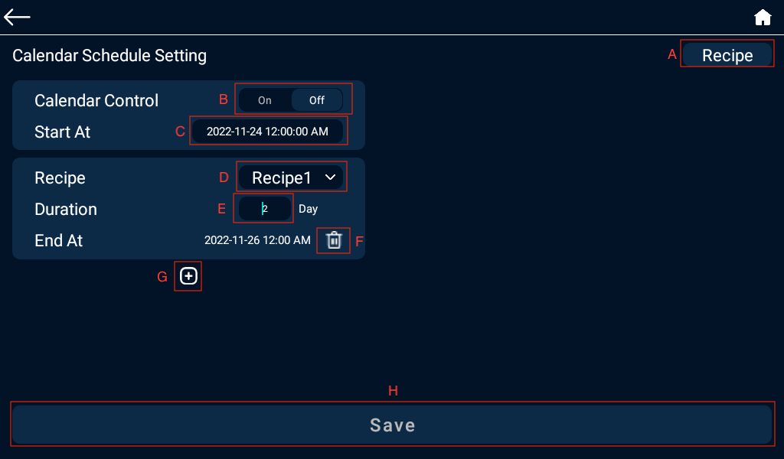

A.配方列表，可新增配方，编辑配方详情；

B.日历控制总开关，On时日程生效；

C.设置日程开始时间；

D.配方名称，下拉可修改；

E.配方持续时长；

F.删除生长阶段；

G.点击图片 5增加生长阶段：选择配方，输入持续天数。

H.保存当前设置；

A. Recipe list user can adding new recipes and editing recipe details.

B. Calendar control switch, schedule takes effect when On.

C. Set calendar start time.

D.Recipe name, drop down to select;

E. Recipe duration.

F. Removethe growth phase.

G. Click to add a growth phase: select the recipe and enter the number of days.

H. Save current settings.

点击右上角[Recipe]进入配方列表页面。

Tap [Recipe] in the top right corner to go to the recipe list page.

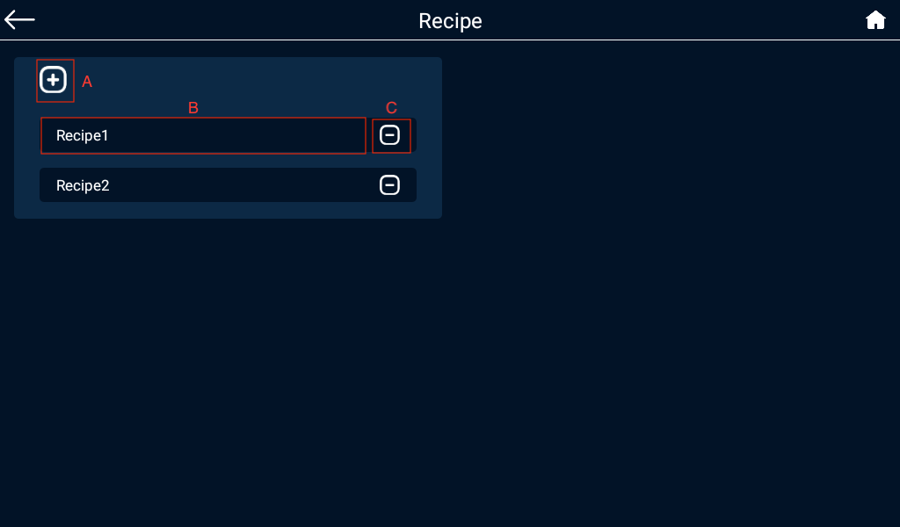

A.新增配方；Add a new recipe

B.查看或编辑配方详情；View or edit the recipe

C.删除配方。Delete a recipe

点击配方进入配方设置页面：Tap to enter the Recipe Setting page.

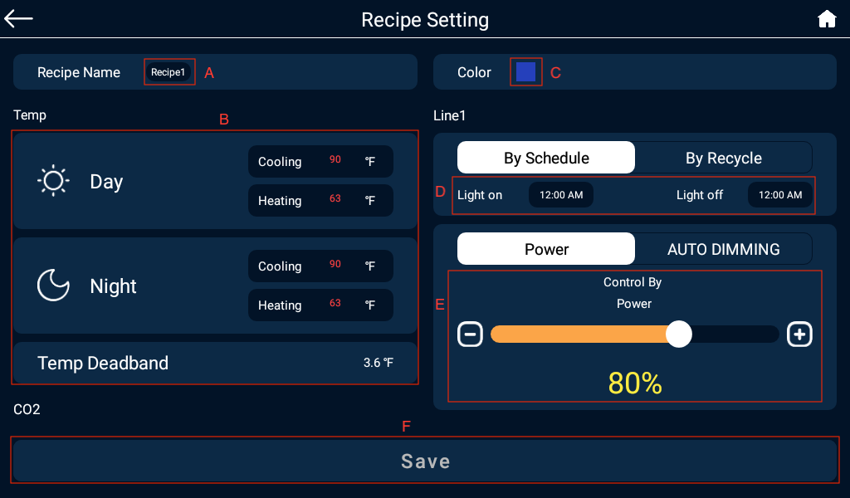

A.置配方名称，可修改；Tap to name the recipe or modified.

B.温度、CO2、湿度各项设置;Temperature, CO2, humidity settings;

C.配方颜色; Recipe color

D.Line的By Schedule开启和关闭时间；Lighting Planby Schedule on and off time.

另外一种By Recycle:开始时间，开启时长，关闭时长；By Recycle: First start time, On time duration, and Off time duration;

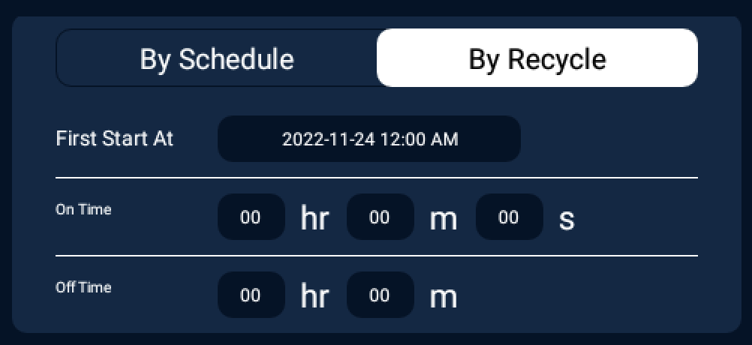

E.Line1灯具输出功率设置；Light output settings

其中：制冷与制热差值必须>= Deadband*2

除湿与加湿差值必须>= Deadband*2

NOTE: Cooling and heating difference must be >= Deadband*2

Dehumidification and humidification difference must be >= Deadband*2

## 温度设置 Temperature Setting

点击首页[Temp]进入温度设置页面。

Tap [Temp] on the home page to enter the temperature setting page.

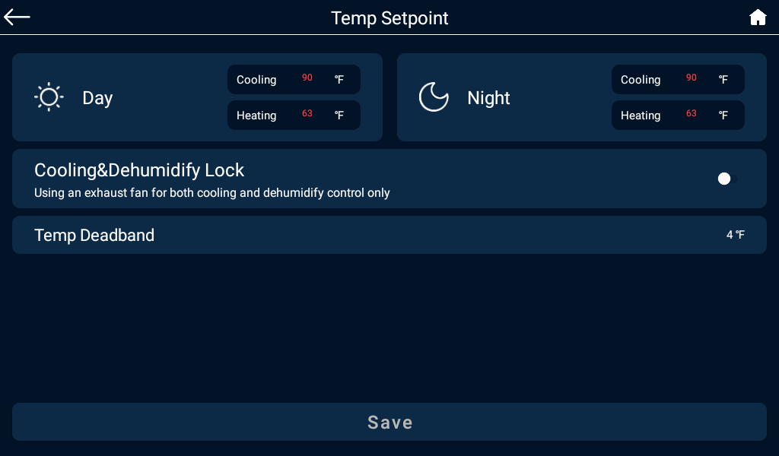

制冷目标值与制热目标值差值必须>= 温度Deadband*2

制冷条件：当温度值>= 制冷目标温度时开启，

当温度值<= 制冷目标温度- Deadband时关闭。

制热条件：当温度值<= 制热目标温度时开启，

当温度值>= 制热目标温度+ Deadband时关闭。

制冷及除湿锁定：只有使用排气扇进行制冷和除湿控制时选中, 仅限于Device Station及 Smart Socket-4。

Cooling trigger value and heating trigger value Difference must be >= Temperature Deadband*2

Cooling condition:

Turn on when the temperature value >= Cooling Trigger Temperature

Turn off when the temperature value <= Cooling Trigger Temperature - Deadband.

Heating condition:

Turn on when the temperature value <= Heating Trigger Temperature

Turn off when the temperature value >= Heating Trigger Temperature + Deadband.

Cooling & Dehumidify lock: selected only when using exhaust fans for cooling and dehumidification control.

## 湿度设置 Humidity Setting

点击首页[Humid]进入湿度设置页面。

Tap [Humid] on the top page to enter the humidity setting page.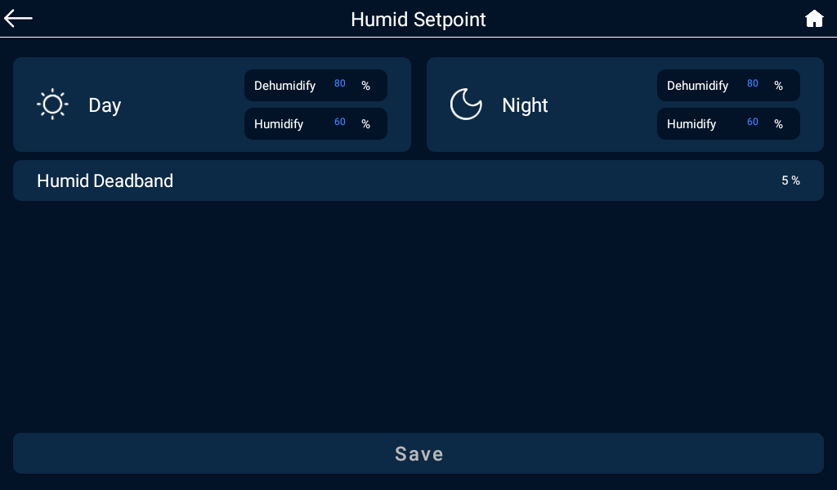

除湿条件：当湿度>= 除湿目标值时开启，

当湿度<= 除湿目标值 - Deadband时关闭。

加湿条件：当湿度<= 加湿目标值开启，

当湿度>= 加湿目标值 + deadband时关闭。

Dehumidification condition:

Turn on when humidity >= Dehumidification Trigger Value

Turn off when Humidity <= Dehumidification Trigger Value - Deadband.

Humidification conditions:

Turn on when humidity <= Humidification Trigger Value

Turn off when humidity >= Humidification Trigger Value + deadband.

## CO2设置 CO2 Setting

点击首页[CO2]进入CO2设置页面。Tap [CO2] on the top page to enter the CO2 setting page.

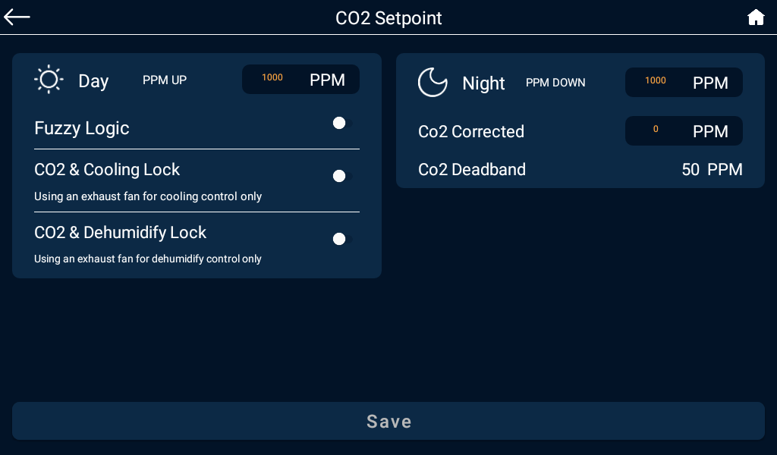

PPM UP只在白天生效。

PPM UP时可选择是否是Fuzzy Logic模式。

CO2及制冷锁定：只在使用排气扇制冷时选中。

CO2及除湿锁定：只在使用排气扇除湿时选中。

CO2 UP条件：当CO2值<= PPM UP目标值时开启，

当CO2值>= PPM UP目标值+ CO2 Deadband时关闭。

CO2修正值：设置修正值后，CO2实时值为CO2传感器值+修正值。

PPM UP is only effective during the daytime.

Grower can select Fuzzy Logic mode when the CO2 tank is the source for PPM UP.

CO2 & Cooling Lock: Checked only when using exhaust fan cooling.

CO2 and Dehumidification Lock: Check only when using the exhaust fan for dehumidification.

PPM UP condition: Turn on when CO2 value <= PPM UP target value.

Turn off when CO2 value >= PPM UP target + CO2 Deadband.

**PPM Down 只在黑夜条件下生效**

**CO2 Down条件：当CO2值>= PPM Down目标值时开启，**

**当CO2值<= PPM Down目标值 - CO2 Deadband时关闭**

PPM Down only works in night mode

PPM DOWN condition: Turn on when CO2 value >= PPM DOWN target value.

Turn off when CO2 value <= PPM DOWN target - CO2 Deadband.

CO2 correction value: After setting the correction value, the CO2 real-time value is CO2 sensor value + correction value.

## VPD

点击首页[VPD]进入VPD页面。Tap [VPD] on the top page to enter the VPD page.

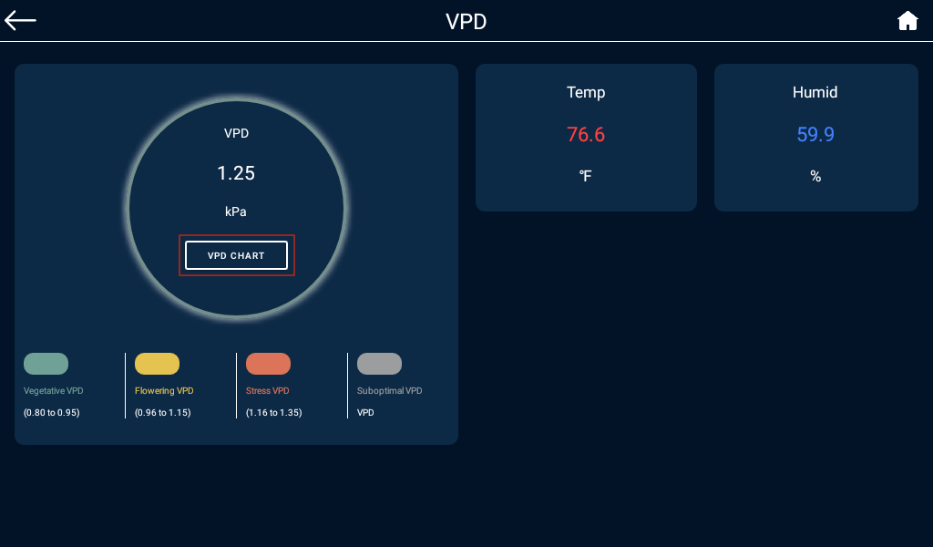

点击[VPD Chart]进入VPD图表页可作为参考值。Tap [VPD Chart] to go to the VPD Chart page as a references.

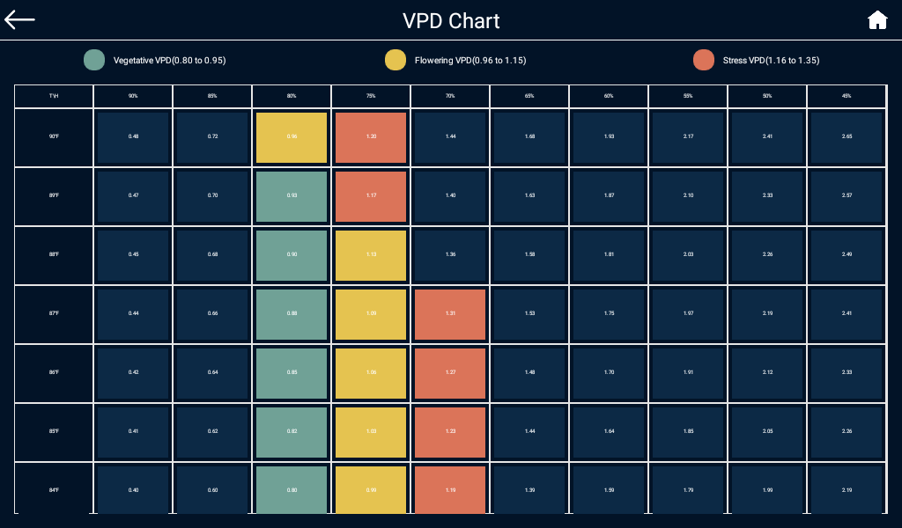

## 光照设置 Lighting Control

点击首页[Light]进入Light页面，包含线路1设置及线路2设置。

Tap [Light] on the home page to enter the Lighting control page, which shows Line 1 settings and Line 2 settings.

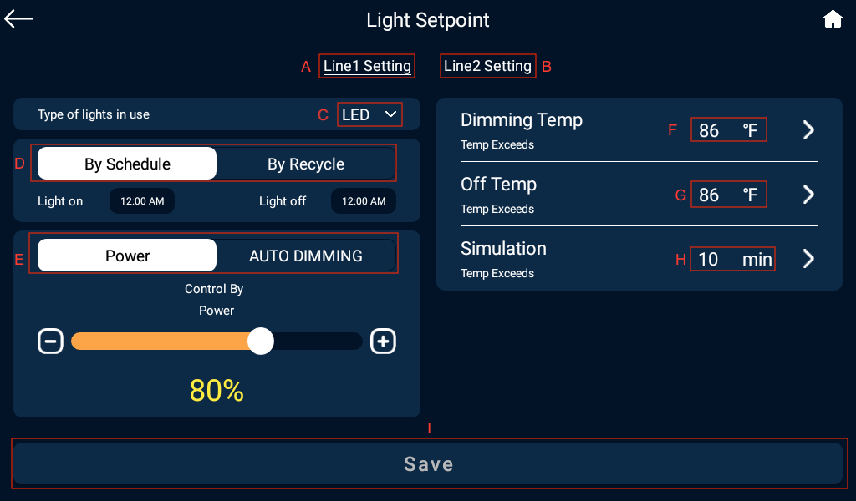

A.线路1灯光设置 Tap to set the Line 1.

B.线路2灯光设置 Tap to set the Line 2

C.灯光类型：LED、HID。其中HID模式可设置HID Delay。Tap to select the fixture type between LED/HID.

D.工作模式：By Schedule及By Recycle。Operating modes: By Schedule and By Recycle.

By Schedule：可设置几点开，几点关。每天循环。最多可设置12组定时器。

By Schedule: You can set the on time and off time. Daily cycle. Up to 12 sets of timers can be set.

By Recycle：可设置第一次开启时间，开启时长，关闭时长。

By Recycle: Start time, on time duration, off time duration.

E.控制模式：POWER：指定灯光输出功率百分比；AUTO DIMMING：需要有PAR传感器,使光照维持在设定的光照值下；只有Line1才有。

F. 自动调温温度:当温度超过设置值时，灯具自动调整为设置值的一半输出，如果调整后低于40%，将设为40%。Automatic dimming temperature : When the temperature exceeds the dimming temperature, the fixtures automatically adjusts to 40% output.

G.关闭温度：当温度超过设置值时，自动关闭。Off temperature: Automatically turn off the fixture when the temperature exceeds the off temperature.

H.日晖控制：模拟日升日落持续时间。 Simulation: Simulate the sunrise and sunset.

I.保存设置；Save the Settings;

## 设备列表 Device List

首页点击[Device]进入设备列表。

Tap [Device] on the home page to enter the device list.

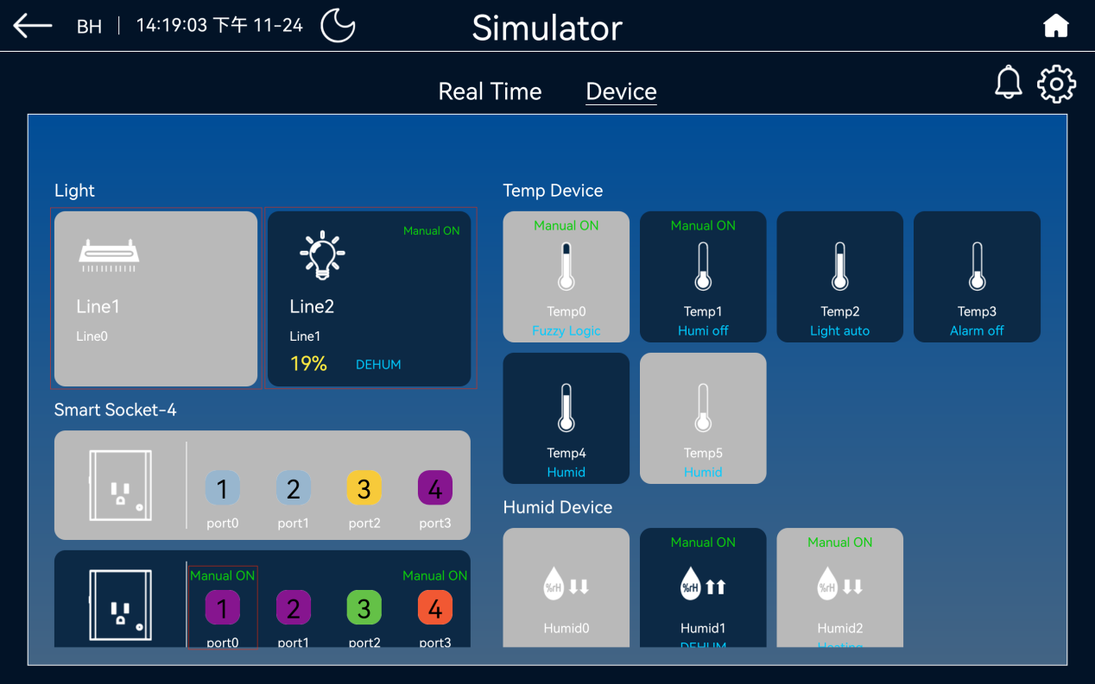

设备掉线时背景变灰，掉线设备支持长按2秒删除。

Device will turn gray when it is offline, offline device can be deleted by 2 sec long press.

常开常关时右上角显示M-ON及M-OFF。

M-ON and M-OFF are displayed in the upper right corner when normally open and normally closed.

设备工作时将显示相应的工作状态。

The corresponding operating status will be displayed when the device is working.

点击设备进入设备设置页面:

Tap on the device to enter the device settings page:

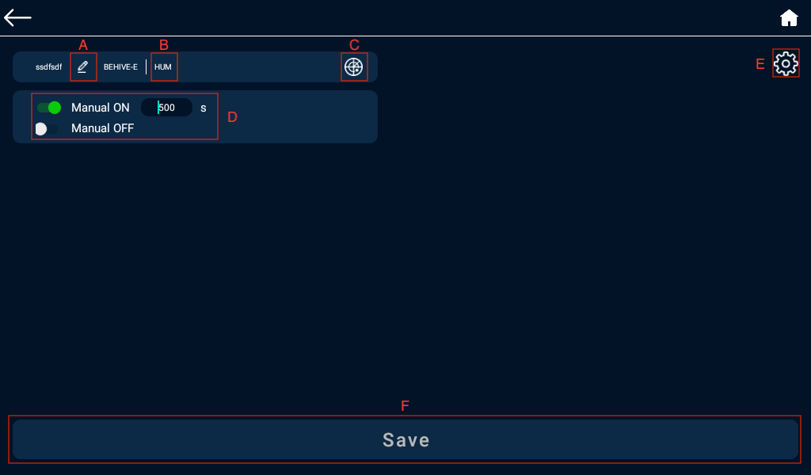

A.点击设备名称图片 19，可修改设备名称，名称规则为最多5个字符，且只支持英文数字及下划线。Tap on the device name to name your device name with 5 characters max

B.AC Station-4，Output12支持修改端口类别，点击最上方设备类型可修改。

C.图片 16：点击可直接设备定位，定位成功时设备会闪烁1分钟。Click to locate the device directly, and the device will flash for 1 minute when it is successfully located.

D.手动开关Manual Switch

手动开：选中后将直接开启N秒，N秒后恢复自动。Manual on: will be directly opened for N seconds after selected, N seconds after restoring automatic.

手动关：选中后关闭设备。Manual Off: Turns off the device when selected.

1. 图片 15：灯光设备/温度设备/湿度设备/CO2设备可点击右上角进入设置。：Lighting device/Temperature device/Humidity device/CO2 device can click the upper right corner to enter the setting. (这个是E)
2. 保存设置 Save settings.

Hot Start Delay：除湿设备、制冷设备、制热设备可选。Hot Start Delay: Optional function for Dehumidification equipment, cooling equipment, heating equipment.



定时设备可设置By Schedule/By Recycle。The program device can be set By Schedule/By Recycle.

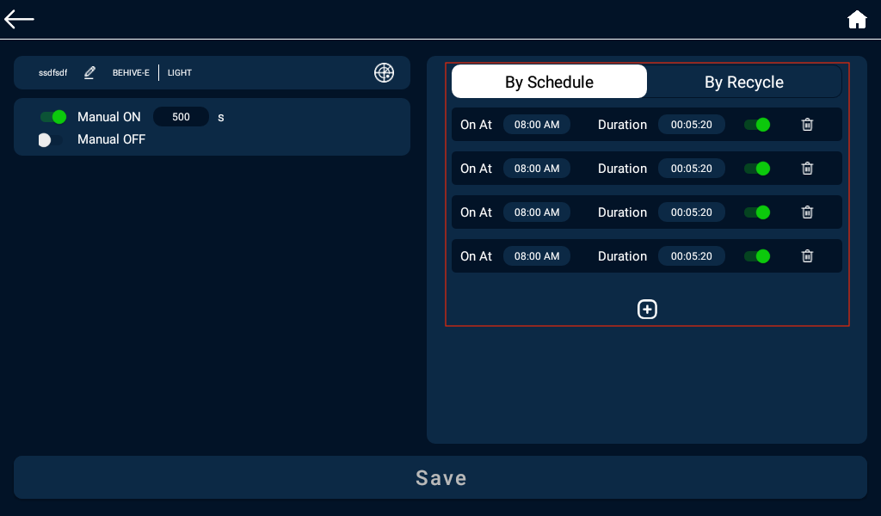

By Schedule：可设置几点开，几点关。每天循环。最多可设置12组定时器。

By Schedule: set the on time and off time. Daily cycle. Up to 12 sets of timers can be set.

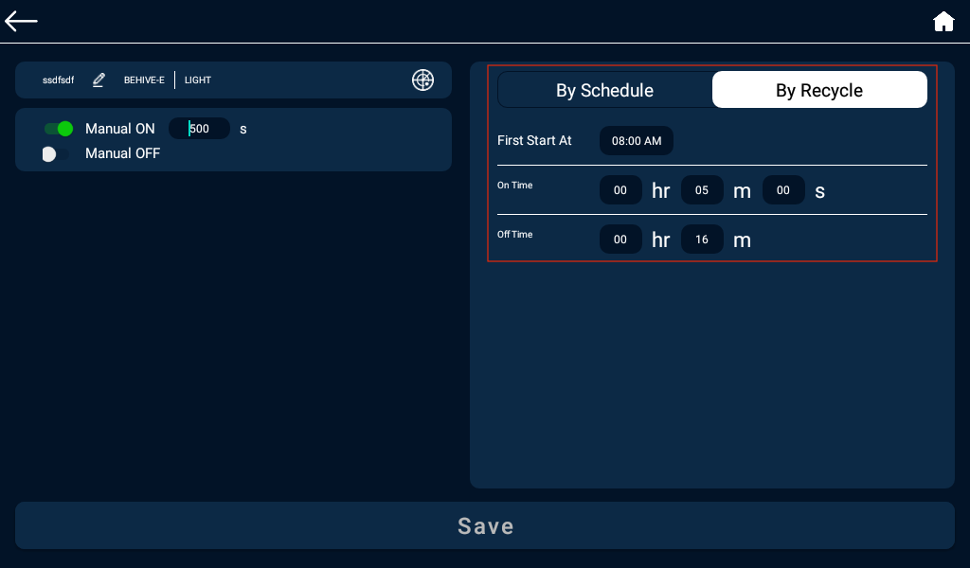

By Recycle：可设置第一次开启时间，开启时长，关闭时长。定时设备常开设置：On Time>0 且Off Time = 0。

By Recycle: set the start time, and on time duration, off time duration. After turning on, it will continuously cycle the on time and off time.

HVAC设备设置界面：HVAC device setting page:

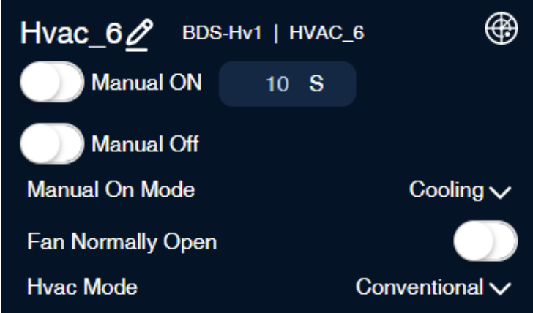

HVAC手动开模式有两种：Cooling、Heating。HVAC has two manual on modes: Cooling, Heating.

可选择风扇是否常开，选中就是常开, 未选中是自动。

Select whether the fan is normally on. If yes, the fan is normally on. If no, the fan is under auto mode.

HVAC模式：Conventional

HVAC mode: Conventional

## 系统设置 BeHive System Setting

设备首页点击右上角图片 23，进入系统设置页面。

Tap on the top right corner of the device home page to enter the system settings page.

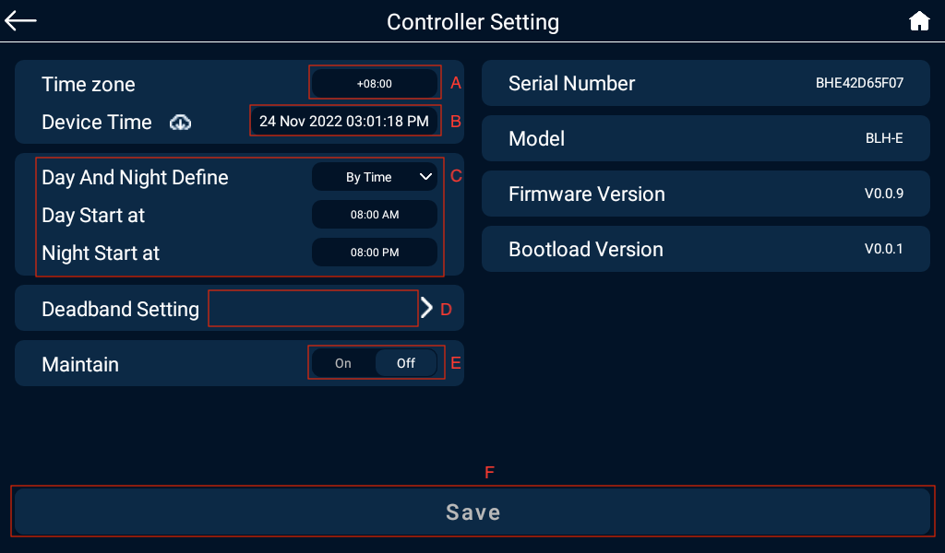

A.时区：设置设备所在的时区; Time Zone: Set the time zone where the device is located.

B.设备日期与时间。每次设备上线时将自动从云端同步一次时间。点击图片 28将同步平板时间至设备; The time will be automatically synchronized from the cloud every time the device comes online.

C.白天黑夜定义：By Photocell/By Time。Day and Night define: By Photocell/By Time

By Photocell：根据设置的Photocell Sensitivity，与当前的Light Intensity比较，大于等 于时是白天，其它是夜晚。

By Photocell: According to the set Photocell Sensitivity, compare with the current Light Intensity, it is daytime when it is greater than or equal to, and other is nighttime.

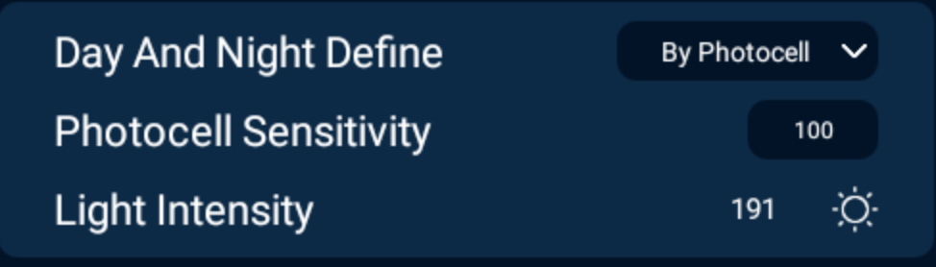

By Time：设置白天起始时间，晚上起始时间。

By Time: Set the daytime start time and nighttime start time.

D.死区值设置：可设置温度、湿度、CO2死区值。Deadband setting: Temperature, humidity and CO2 deadband values can be change here.

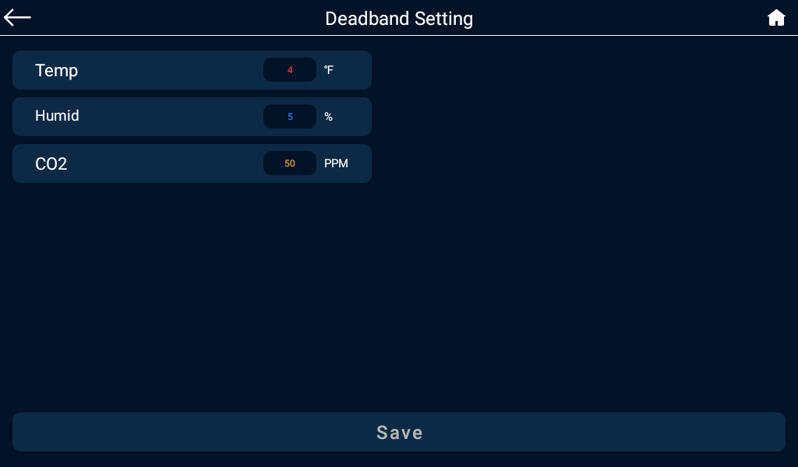

1. 检修模式：选中后所有设备将停止工作，只监测数据。同时首页将会显示检修标志图片 30. Maintenance mode: When selected, all devices will stop working and only data will be monitored.

F.保存设置；Save settings.

## 报警相关 Alarm Setting

首页点击图片 31进入报警列表页。Tap the  icon on the homepage to enter the alarm list page.

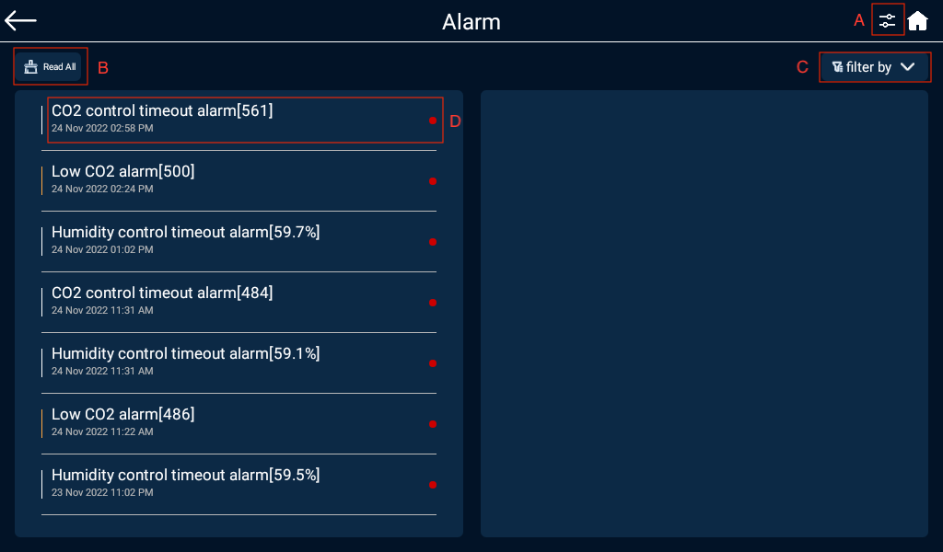

右上角点击图片 36进入报警设置页面，可对温度、湿度、CO2等报警开关及报警上下限设置。Tap  on the upper right corner to enter the alarm setting page, you can switch on/off the alarm and the day/night MIN and MAX alarm limits for temperature, humidity, CO2, VPD and PAR.

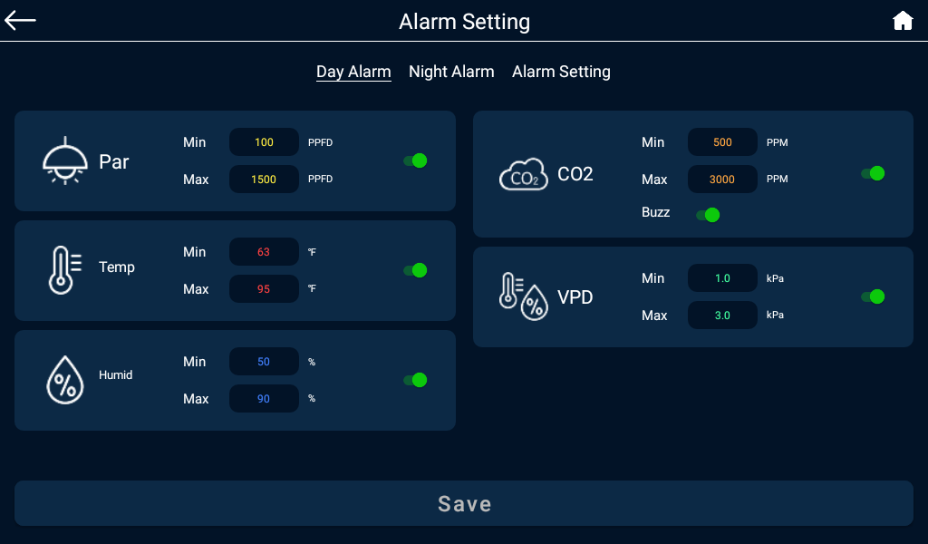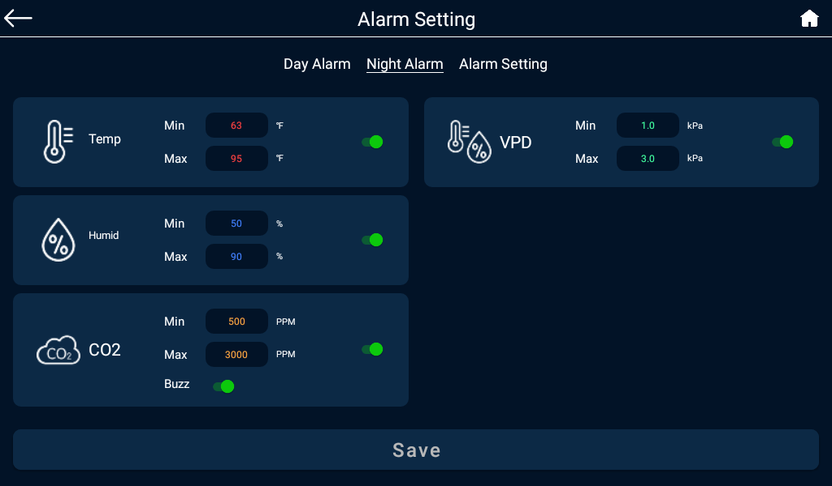

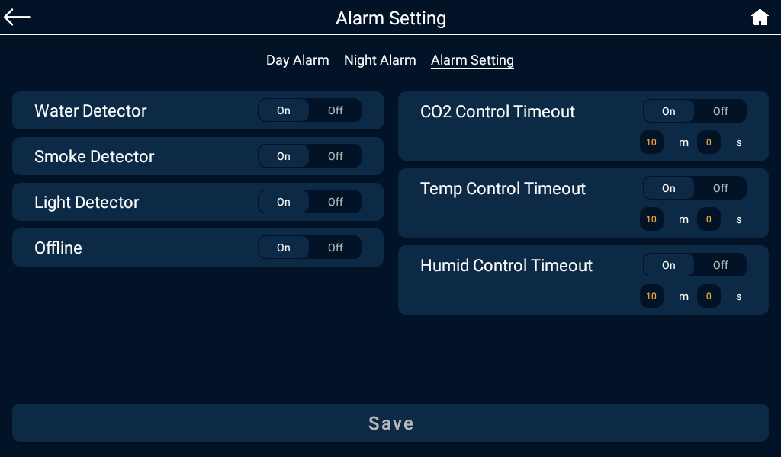

B.标记全部已读：点击后所有信息将全部已读。Read All: All messages will be read when you click on them.

C.筛选条件: 下拉可按设备，温度，湿度，CO2等过滤相关报警信息Filter by: Scroll down to filter alarm information by device, temperature, humidity, CO2, etc.

图片 34表示信息未读，点击后已读，红色标记将消失。

Indicates that the alarm message has not been read, and the red mark will disappear when it has been read after clicking.

## APP设置

打开APP，设备列表界面右上角的图片 23进入APP设置页面。

Log in the APP, tap the 图片 23 to enter the APP setting page.

可设置语言、温度单位、EC单位、时间格式等。

Select the language, temperature unit, EC unit, and time format.

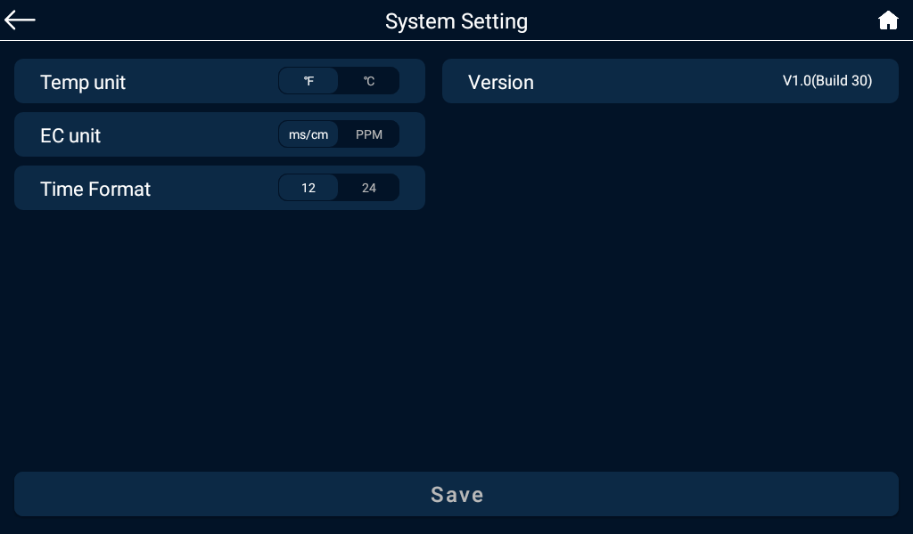

温度单位: 可根据用户的需求选择温度单位

EC单位: 可根据用户的需求选择EC单位

时间格式:可根据用户的需求选择时间格式

Temperature unit: Select temperature unit according to the user's needs

EC unit: Select an EC unit based on user needs

Time format: Select the time format according to the user's needs